A Mini Project Report
on
SkillRadar: A Gamified 3D Career Exploration and Skill Development Platform for College Students
Submitted in partial fulfilment of the requirements for the completion of Third Semester in Bachelor of Business Administration (Artificial Intelligence)
Submitted by
Jaanvi Rai – (PRN: 25030422052)
Aina Jain – (PRN: 25030422012)
Sannidhi Mutyala – (PRN: 25030422075)


Submitted to
Dr. Bela Joglekar
Associate Professor
Symbiosis Artificial Intelligence Institute (SAII साई),
Symbiosis International (Deemed University), Pune 412115
Oct 2026

Table of Content
Sl. No. | Content Title | Page
1 | Declaration | 1
2 | Certificate | 2
3 | Abstract | 3
4 | Introduction | 3
5 | About Career Guidance Tools | 4
6 | Role Families Targeted | 5
7 | Dataset and Data Provenance | 6
8 | Data Quality Checks | 6
9 | System Design and Methodology | 8
10 | Role Alignment Score | 8
11 | Technology and Deployment | 9
12 | Modules Implemented | 9
13 | Skill Scan Lab | 10
14 | Career Explorer | 13
15 | Job Simulation Arena | 14
16 | Skill Gap Analysis and Upgrade Station | 15
17 | Model Evaluation | 17
18 | Role Classifier Results | 18
19 | Confusion Matrix Analysis | 20
20 | Salary Prediction Model | 21
21 | Source Code, Deployment and Market Estimate | 23
22 | GitHub Repository | 23
23 | Deployment on Vercel | 23
24 | AI Assistant | 24
25 | Market Estimate: TAM, SAM, SOM | 24
26 | Results and Discussion | 25
27 | Future Scope | 27
28 | Conclusions | 27
29 | References | 27

DECLARATION

We hereby declare that the Mini Project Report entitled “SkillRadar: A Gamified 3D Career Exploration and Skill Development Platform for College Students” which is being submitted to Symbiosis Artificial Intelligence Institute (SAII साई), Symbiosis International (Deemed University) in partial fulfillment of the requirements for the completion of Third semester in Bachelor of Business Administration (Artificial Intelligence) is a bonafide report of the work carried out by us. The material contained in the report has not been submitted to any University or Institution.

Jaanvi Rai  (PRN: 25030422052) | Aina Jain  (PRN: 25030422012) | Sannidhi Mutyala  (PRN: 25030422075)

Place: SAII, SIU, Pune
Date: 28/10/2026

CERTIFICATE

This is to certify that the Project Report entitled “SkillRadar: A Gamified 3D Career Exploration and Skill Development Platform for College Students” submitted by Ms. Jaanvi Rai (PRN: 25030422052), Ms. Aina Jain (PRN: 25030422012) and Ms. Sannidhi Mutyala (PRN: 25030422075) as record of the work carried out by them, is accepted as Report submission in partial fulfilment of the requirements for the completion of third semester in Bachelor of Business Administration (Artificial Intelligence).

Internal Project Guides

Dr. Bela Joglekar
Associate Professor

External Project Guides

Mr. Sanchit Mehrotra | Mr. Chetan Bais
Co-Founder, Zeeplework | Co-Founder, Zeeplework

SkillRadar: A Gamified 3D Career Exploration and Skill Development Platform for College Students
Jaanvi Rai, Aina Jain, Sannidhi Mutyala
Symbiosis Artificial Intelligence Institute, Symbiosis International University, Pune - 412115.
Abstract
Most college students pick a career without really knowing what employers ask for, how their own skills measure up, or what they should study next. Job portals, skill tests and course websites each solve only one of these problems. In this project we built SkillRadar, a web platform that brings all three together. The platform is set inside a walkable 3D spaceship hub, and it also has a plain 2D console mode for slower computers. It has seven rooms covering onboarding, skill testing, career exploration, role matching, job simulations, a learning roadmap and a progress dashboard. Everything is based on an audited workbook of about 16,000 cleaned job postings, 66 standard roles and 136 skills. Skills are saved as quiz-verified, simulation-verified or self-reported, and a fixed weighted formula gives a role-fit score together with an evidence-completeness percentage so that students do not over-trust a score built on very little data. A weekly roadmap is then created from the gaps. In our demo profile the Data Analyst fit came out at 31% with 42% evidence completeness.
Keywords: Career guidance, Skill gap analysis, Gamification, Job simulation, Explainable scoring, Labour market data, 3D web application
1. INTRODUCTION
Choosing a career is a big decision, and most of us make it with very little real information. We look at a few job websites, ask seniors, maybe watch some videos, and still do not know how ready we are for a role like Data Analyst or Business Analyst. Job portals only list vacancies. Online quizzes only give marks. Learning websites only offer courses. Nobody tells us how far we are from a particular job and what to do about it this week.
Another problem is that companies describe the same skill in many different ways in their postings. One says “SQL”, another says “database querying”, another says “MySQL/PostgreSQL”. Before this data can help a student, it has to be cleaned and brought to one standard. Also, a score that says “you are 72% ready” is not useful unless the student can see how that number was calculated.
With this in mind we set four objectives for SkillRadar. First, let students explore roles, salaries and hiring cities from a real dataset. Second, measure skills through quizzes and job simulations and keep track of what kind of evidence each skill has. Third, calculate a role-fit score using a formula that is visible to the student. Fourth, turn the gaps into a weekly study plan that matches the hours a student actually has. To keep it interesting we wrapped everything in a game-like 3D space station, because a plain form-based tool is something many of us would stop using after one day.
The current version covers three role families (Data Analyst, Financial Analyst and Business Analyst), although the role catalogue itself has 66 roles. SkillRadar is meant for learning and self-assessment only. Its scores show how closely a student matches the requirements found in our dataset, and they are not a promise or a prediction of getting a job.
1.1 Motivation
The idea for this project came from our own experience as third-semester students of the BBA (Artificial Intelligence) programme. Many of us are interested in roles such as Data Analyst, Business Analyst or Financial Analyst, but when we looked for guidance we found that every website answered only a small part of our question. We could see salaries on one site, a list of skills on another and a random SQL quiz on a third. None of them told us, in one place, how far we were from a role and what to do about it.
We also noticed that most career tools feel like long forms. After filling a few pages the student gets a result and closes the tab. We wanted something that students would actually enjoy opening again, and that is why we decided to build the whole experience as a small game world, while keeping the content and the scoring serious and data-based.
1.2 Problem statement
Students do not have one trustworthy place where they can (a) explore job roles backed by real market data, (b) measure their skills in a way that separates verified evidence from self-claims, (c) see exactly how far they are from a target role, and (d) get a concrete plan to close that gap. Existing tools usually solve only one of these four points and do not explain how their scores are produced.
1.3 Objectives of the project
• To build an interactive platform that lets students explore job roles, salaries and hiring cities drawn from a real, audited dataset.
• To assess skills through scenario-based quizzes and practical job simulations and to record each skill along with the type of evidence behind it.
• To calculate a role-alignment score using a deterministic weighted formula and to report how complete the evidence behind the score is.
• To generate a personalised weekly learning roadmap from the identified skill gaps and the study hours available to the student.
• To present everything through a 3D hub with a 2D console fallback, and to keep the project easy to deploy on open-source platforms.
1.4 Scope of the work
The current version focuses on three role families, namely Data Analyst, Financial Analyst and Business Analyst. The role catalogue itself holds 66 standard roles and the skill taxonomy holds 136 skills, so the Career Explorer and the matching engine can work for many more roles than the ones for which we wrote simulations. SkillRadar is meant for learning and self-assessment only. Its scores show how closely a student matches the requirements found in our dataset, and they are not a promise or a prediction of getting a job.
1.5 Organisation of the report
Section 2 gives the background on career guidance tools and the role families we targeted. Section 3 describes the dataset, its sources and its quality audit. Section 4 explains the system design, scoring method and deployment. Section 5 walks through every module with screenshots. Section 6 evaluates the machine learning models stored in the dataset, Section 7 covers the GitHub repository, deployment, AI assistant and market estimate, Section 8 presents the results and discussion, Section 9 lists the future scope and Section 10 concludes the report.
2. ABOUT CAREER GUIDANCE TOOLS
2.1 Why students struggle
Students usually face three separate questions: what roles exist, how good am I right now, and what should I learn next. The answers sit on different websites that do not talk to each other. A student may take a SQL quiz on one site, read job posts on another and follow a course on a third, and never see how these three connect.
2.2 Existing kinds of tools
• Job portals list thousands of postings and let us filter by title and city, but they do not measure the student.
• Assessment sites give a score for aptitude or a particular technology, but the score is not linked to what a specific job needs.
• Learning platforms teach well, yet the learner has to decide on their own which skill matters most.
SkillRadar tries to sit in the middle of these three so that the output of one step becomes the input of the next.
2.3 Gamification and honest scoring
Points, levels and badges are commonly used to keep learners motivated. We use the same idea (XP, clearance levels and seven badges), but points are given only for verified activity such as passing a quiz or finishing a graded simulation. We also decided early that every skill must carry a label showing whether it was verified or just self-reported, because a profile full of self-claims would make the fit score look better than it really is.
2.4 Role families targeted in this version
We chose three roles for the full workflow of quizzes and simulations because they share many skills and are common first jobs for business and AI students.
• Data Analyst: collects, cleans and analyses data to answer business questions and builds reports and dashboards. In our dataset this role has 67 postings and a median salary of ₹6.0 lakh per year. The skills that matter most are SQL, Excel, Power BI, Python and problem solving.
• Financial Analyst: works with ratios, margins and investment decisions. The simulation for this role asks the student to judge liquidity and solvency and to give a recommendation on a capital expense.
• Business Analyst: connects business and technical teams by studying processes, collecting requirements and suggesting solutions. In our dataset this role has 97 postings and a median salary of ₹7.3 lakh per year.
2.5 Why a standard skill taxonomy is needed
Job postings are written by different people in different companies. A recruiter may write “MS Excel”, “Microsoft Excel” or just “advanced Excel” and all three mean the same thing. If we count them separately, the importance of the skill gets split and the match score becomes unreliable. For this reason the dataset contains a taxonomy sheet with 136 standard skill entities, each having a definition, aliases and a count of how often the skill is mentioned. The same definition is shown to the student on the self-assessment screen, so the student and the system are both talking about the same thing.
2.6 Gaps that this project tries to fill
• Connecting real labour-market data with personal skill evidence in one workflow.
• Separating quiz, simulation and self-reported evidence so that the profile cannot be inflated.
• Giving a learning roadmap whose milestones need demonstrated practice, not just reading.
• Showing the limitations of the data inside the product itself instead of hiding them.
3. DATASET AND DATA PROVENANCE
3.1 Data description
All data used in the platform comes from one audited workbook, Dataset.xlsx (about 8.8 MB, 15 sheets). The sheets and their roles in our project are listed in Table I. In total the workbook holds 16,459 raw job rows, out of which 16,001 clean job postings were kept after cleaning. The skill taxonomy has 136 skills and the role sheet has 66 standard roles.
Table I: Sheets of Dataset.xlsx and their role in SkillRadar
Sheet | Rows | Role in the project
README | 18 | Scope of the template and dataset limitations
01_Source_Register | 8 | Where each source came from (Fliar BI, LinkedIn sample, Headcount Labs)
02_Raw_Jobs | 16,459 | Raw postings from India and international tech samples
03_Clean_Jobs | 16,001 | Cleaned titles, role IDs, INR salaries and cities
04_Skill_Taxonomy | 136 | Standard skills with definitions and aliases
05_Job_Roles | 66 | Standard job roles and role families
06_Extracted_Skills | 12,324 | Which skills each posting asks for, required or only mentioned
07_Gold_Labels | 992 | Human-checked ground-truth records
08_Feature_Table | 1,000+ | Features for NLP and tabular models
09_Predictions | 1,000+ | Model outputs
10_Model_Evaluation | 100+ | Precision, recall and F1 results
11_Data_Quality | 11 | Quality checks Q001 to Q010
12_Data_Dictionary | 155 | Meaning and type of every field
13_Import_Plan | 50+ | Schema validation rules
14_Market_Benchmarks | 515 | Market-level counts, employers and monthly trends

3.2 Sources
The salary data is from Fliar BI (SRC001, licence CC BY-NC 4.0), where salaries are in INR and the annual period is inferred. The tech job postings come from a LinkedIn sample (SRC006) that is used as an educational research sample. Another source, Headcount Labs (SRC004), is also listed in the source register. Because the Fliar BI licence is non-commercial, SkillRadar is strictly an educational project.
3.3 Data quality checks
Sheet 11 has ten acceptance checks (Q001 to Q010). We felt these should not be hidden in a file, so we show them inside the app in a “Dataset Provenance & Quality Audit” window (Fig. 1). For example, Q001 checks that job IDs are unique, and exact LinkedIn duplicates are kept only with a suffix and excluded. Q002 removes 171 duplicate LinkedIn rows and also points out that around 4.0% of Fliar company-and-title groups repeat across months, which is normal. Q003 is marked as a flag, since Fliar and Headcount rows have no descriptions by design and only 2,057 rows can be used for text-based NLP.
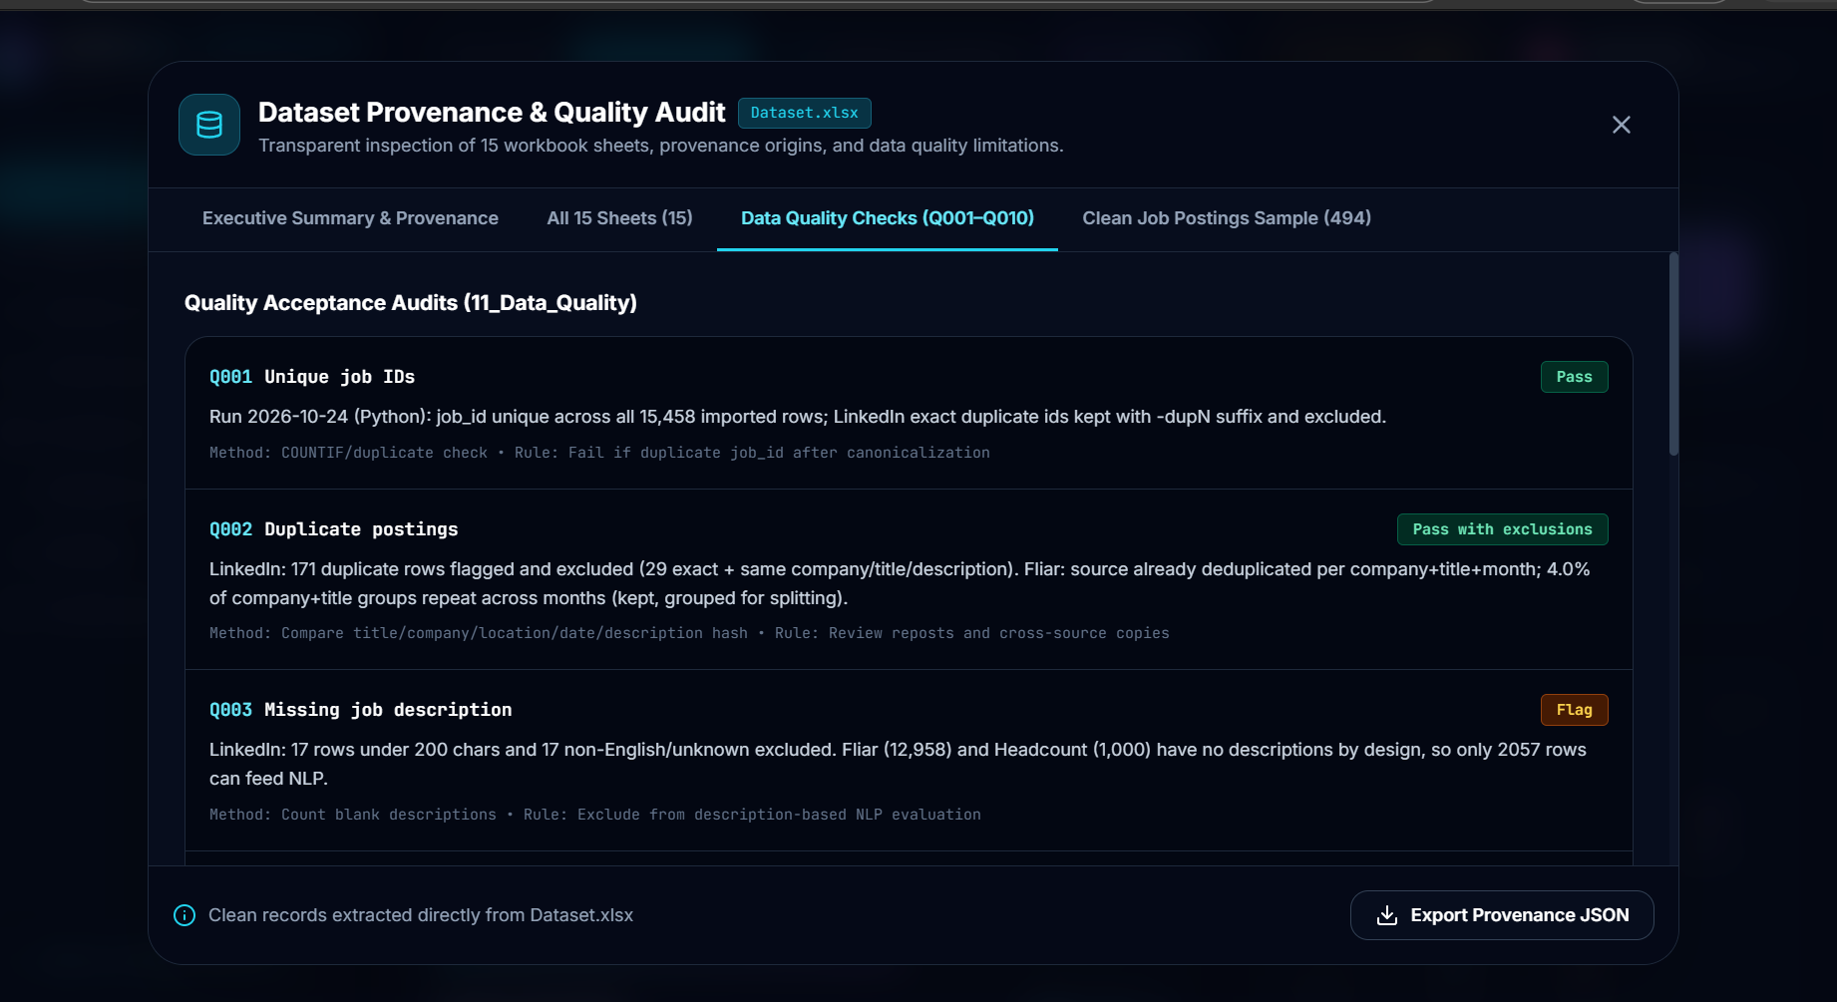
Fig. 1: Dataset Provenance & Quality Audit window (checks Q001 to Q003)
3.4 Known limitations of the data
• Fliar BI salaries are treated as annual values, but this period is inferred and not stated in the source.
• Only the LinkedIn rows have full job descriptions, so text analysis is limited to about 2,057 postings.
• Match scores only show alignment with the modelled requirements. They are never a probability of getting hired.
3.5 Cleaning and standardisation
The raw sheet has 16,459 rows staged from India and international tech samples. During cleaning, job titles were normalised, each posting was mapped to one of the standard role IDs, salaries were converted to INR and locations were mapped to cities such as Bangalore, Mumbai, Pune, Delhi NCR and Hyderabad. After duplicates and unusable rows were removed, 16,001 clean postings remained. These cleaned records are what the Career Explorer and the AI Advisor read from.
3.6 Skill extraction and requirement types
The extracted-skills sheet links postings with skills and holds 12,324 relations. Every relation is marked either as required or only mentioned, and carries a confidence score. This difference matters to us because a skill that is required for a job should weigh more in the fit score than a skill that is only mentioned in passing. The 992 gold-label records were checked by humans and act as ground truth when the extraction quality is evaluated.
3.7 Market benchmarks
The last sheet has 515 rows of macro-level information such as number of postings, employer distribution and monthly benchmarks. Right now we mostly use it for background numbers in the Career Explorer, but it is also the base for the trend features we would like to build in the future.
4. SYSTEM DESIGN AND METHODOLOGY
4.1 Overall architecture
SkillRadar is a single-page web application that runs in the browser. The cleaned dataset is converted into structured records that the interface reads directly, so no separate server is needed for the main features. A student’s profile, evidence ledger, simulation attempts, XP and roadmap progress are all stored by the application. The production build is just static files, which makes deployment easy.
There are two ways to use it. The 3D Hub is a circular station deck with seven portal gateways. The student moves a customised astronaut crewmate with WASD or arrow keys, the camera follows from behind, and when the student gets close to a portal a prompt “Press E or Click to Enter” appears. The 2D Console shows the same seven rooms as a simple grid (toggled with the V key), which helps on low-end laptops and for keyboard-only use.
4.2 Evidence model
Each skill in the profile is saved with a level from 1 to 5, a date and an evidence type. There are three types: Quiz (awarded after passing a scenario question), Simulation (awarded after a graded practical task) and Self-Reported (typed in by the student on a 1 to 5 scale and clearly tagged as unverified). Keeping these apart means a student cannot raise their fit score simply by rating themselves higher.
4.3 Role alignment score
For a chosen role, every required skill i has a weight (Critical = 1.0, Required = 0.8, Preferred = 0.5) and a target level. We compare the demonstrated level with the target, cap the ratio at 1, multiply by the weight, add everything up and divide by the total weight:
Score = [ Σ ( W_{i} × min( D_{i} / T_{i} , 1.0 ) ) / Σ W_{i} ] × 100 ...Eq.1
Here W is the weight, D the demonstrated level and T the target level. Next to the score we also show Profile Evidence Completeness, which is the share of the role’s skills that have verified evidence. If it is below 40%, the app warns the student not to treat the score as exact. Skills are then sorted into matched (demonstrated is at least the target), partial (at least 50% of the target), gaps (high deficit) and unassessed (not tested yet).
4.4 Simulation grading
The job simulations are checked with a fixed rubric. Each task has itemised points and written feedback, so the same answer always gets the same marks, and every attempt is saved in an attempt history.
4.5 Learning roadmap
The roadmap generator takes the skill deficits for the target role and the weekly study hours chosen by the student (4, 8, 15 or 20) and spreads the work over weeks. Each milestone has an objective, a practical project, an official learning link and a completion criterion. We made a rule that reading alone never counts: a milestone is done only after a passed assessment or a verified simulation result.
4.6 Gamification layer
Verified activity gives XP and raises the clearance level. There are seven badges (First Orbit, Data Pioneer, Orbit Explorer, Calibration Ace, Simulation Veteran, Master Strategist and Station Commander). A collapsible mission board shows overall progress, and a small circular radar map lets the student jump to any room. Sound effects are generated through the Web Audio API, so the project does not need any audio files.
4.7 Worked example of the score
To make Eq. 1 easier to understand, here is a small illustrative example (the numbers are only for explanation and are not taken from the dataset). Suppose a role needs three skills: SQL (Critical, weight 1.0, target 5), Excel (Required, weight 0.8, target 5) and Python (Preferred, weight 0.5, target 4). A student has demonstrated SQL at level 3, Excel at level 4 and Python at level 2. The capped ratios are 3/5 = 0.6, 4/5 = 0.8 and 2/4 = 0.5. The weighted sum is 1.0 × 0.6 + 0.8 × 0.8 + 0.5 × 0.5 = 0.6 + 0.64 + 0.25 = 1.49, and the total weight is 1.0 + 0.8 + 0.5 = 2.3. The score is therefore 1.49 / 2.3 × 100, which is about 65%. If the student reached level 5 in SQL, the ratio would become 1.0 and the score would go up to about 76%, which shows clearly why the most critical skill gives the biggest gain.
4.8 Navigation and controls
The 3D hub can be used completely from the keyboard. Table II lists the controls available to the student.
Table II: Keyboard controls of the 3D Hub
Key | Action
W A S D / Arrow keys | Move the crewmate around the deck
E (or click) | Enter the room that is nearest
V | Switch between 3D Hub and 2D Console
H | Show or hide the control hints
Esc | Return to the 3D deck from any room

4.9 Technology and deployment
The project needs Node.js 18 or later (we tested it on Node v24) and npm 9 or later. After downloading the code, the commands npm install, npm run dev, npm run build and npm run preview install the packages, start the development server, create the production bundle and preview it. The application opens at http://localhost:3000 in the browser.
For deployment, the project comes with ready configurations for several platforms. With Docker, the command docker compose up -d --build creates a container that serves the built files through Nginx on port 3000. The same Dockerfile and nginx.conf can be used on Coolify, CapRover or Dokku just by pointing the platform to the Git repository, and Nginx is set up with single-page-app routing. For Vercel and Netlify, the files vercel.json and netlify.toml already contain the build commands and redirect rules, so a single deploy command is enough. Because the output is only static files, hosting costs are very low.
5. MODULES IMPLEMENTED
This section goes through the seven rooms with screenshots from the working application. The student shown in the screenshots is a demo profile.
5.1 3D Hub and 2D Console
The student starts on a circular station deck with glowing rings, a cyan outer edge and a holographic sphere in the middle. Fig. 2 shows the deck from the default camera, and Fig. 3 shows the prompt that appears when the avatar reaches the Simulation Arena. A button at the bottom left switches to the 2D mode.
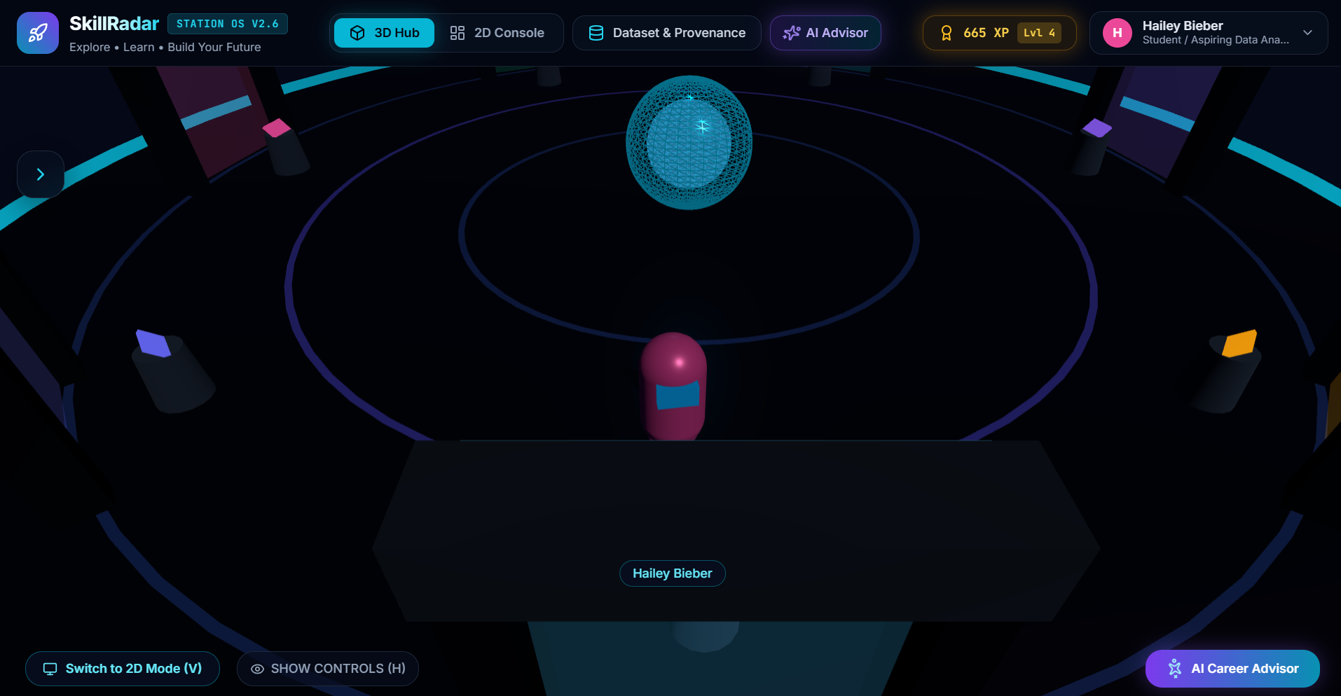
Fig. 2: 3D Hub: walkable station deck with the crewmate avatar
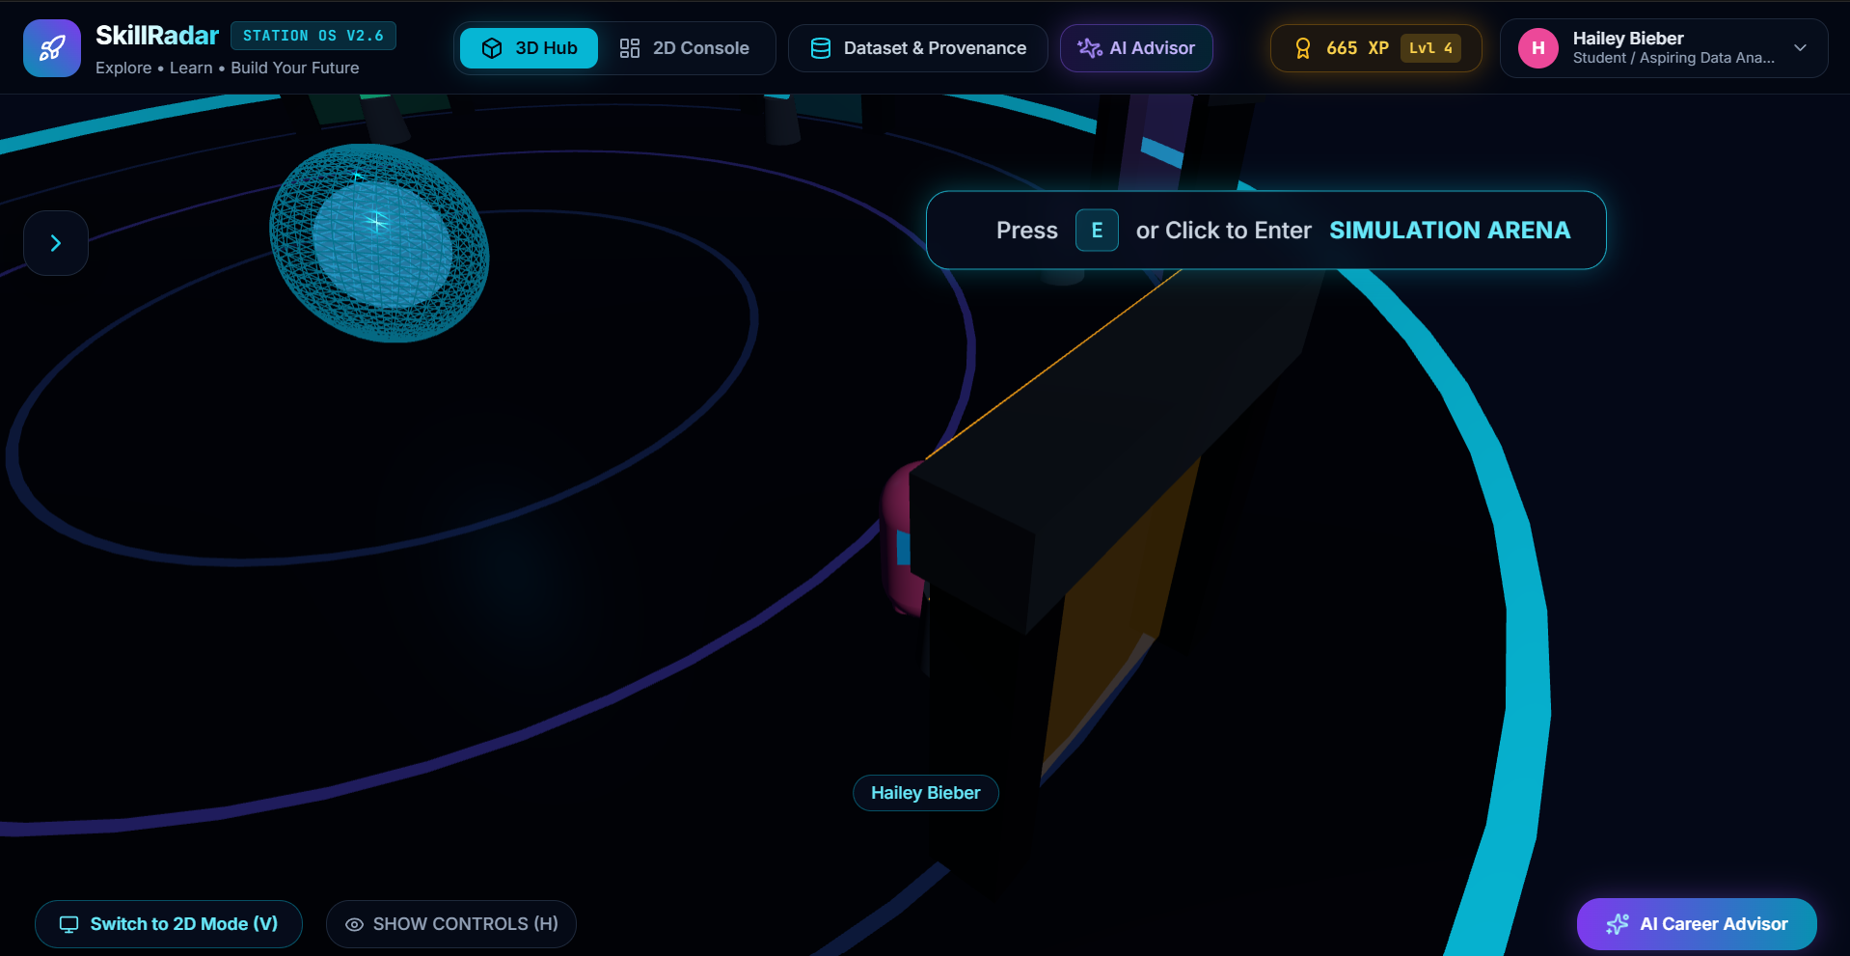
Fig. 3: Proximity prompt for the Simulation Arena and the Switch to 2D Mode button
5.2 Station Lobby
The lobby is the onboarding room. The student enters name, education background, major and career interests and picks a suit colour. This information sets the greeting, the default target role and the profile shown in the top bar.
5.3 Skill Scan Lab
This room has three tabs. In Scenario Quizzes, each question is a small real-life problem, often with a code snippet, on SQL, Excel, Python, Power BI, Statistics or Problem Solving. The question in Fig. 4 asks which clause filters grouped results. Selecting the correct option, HAVING COUNT(order_id) > 5, is shown in Fig. 5 along with the level that will be recorded as verified evidence.
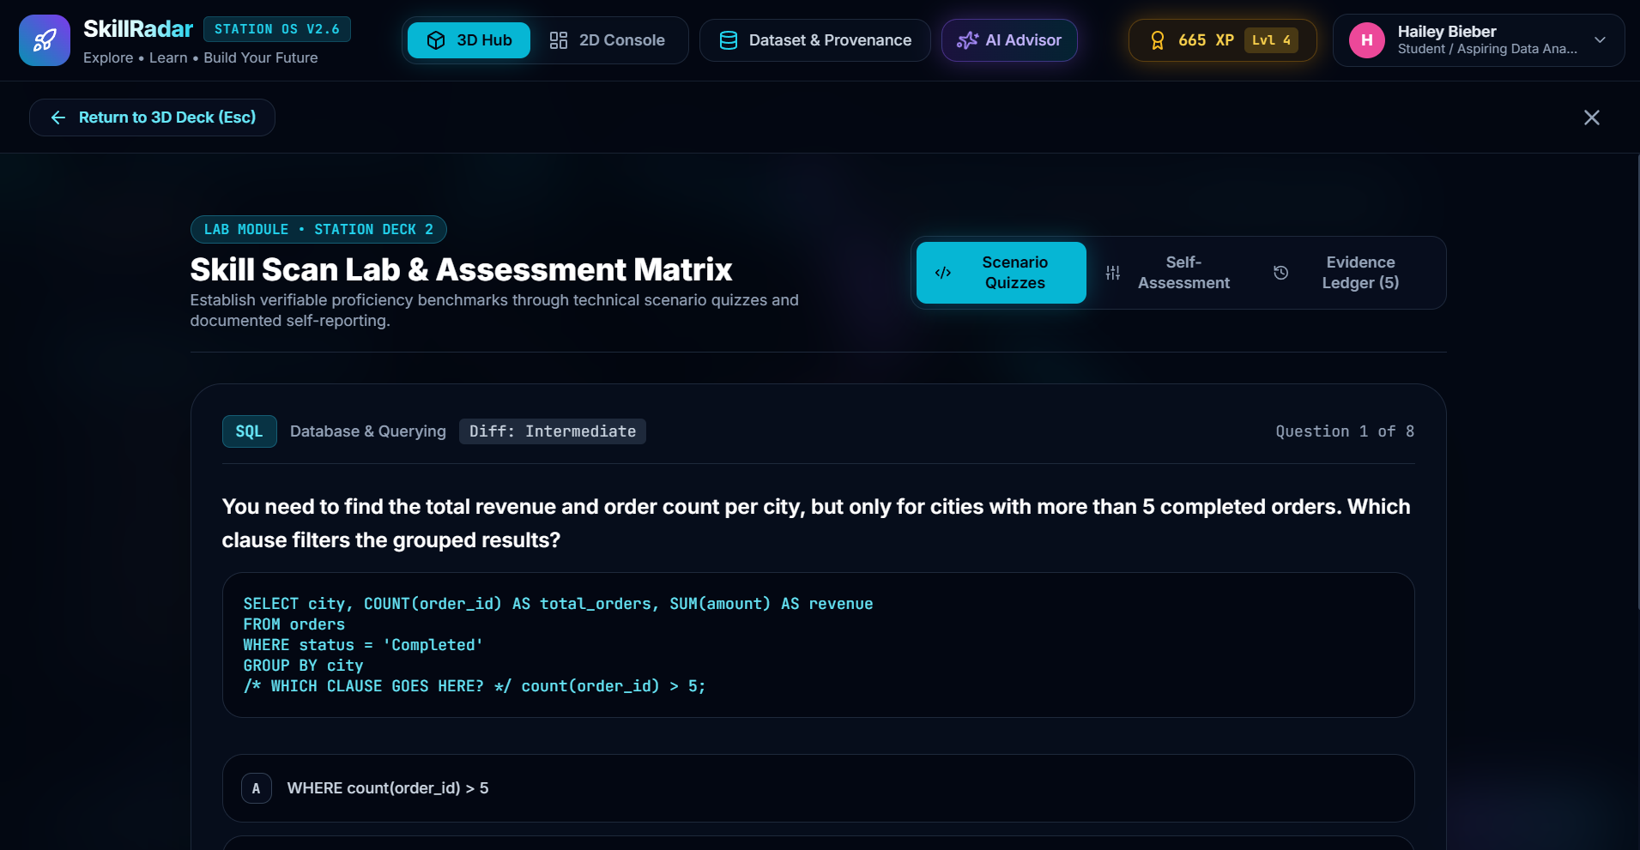
Fig. 4: Scenario quiz: SQL question 1 of 8
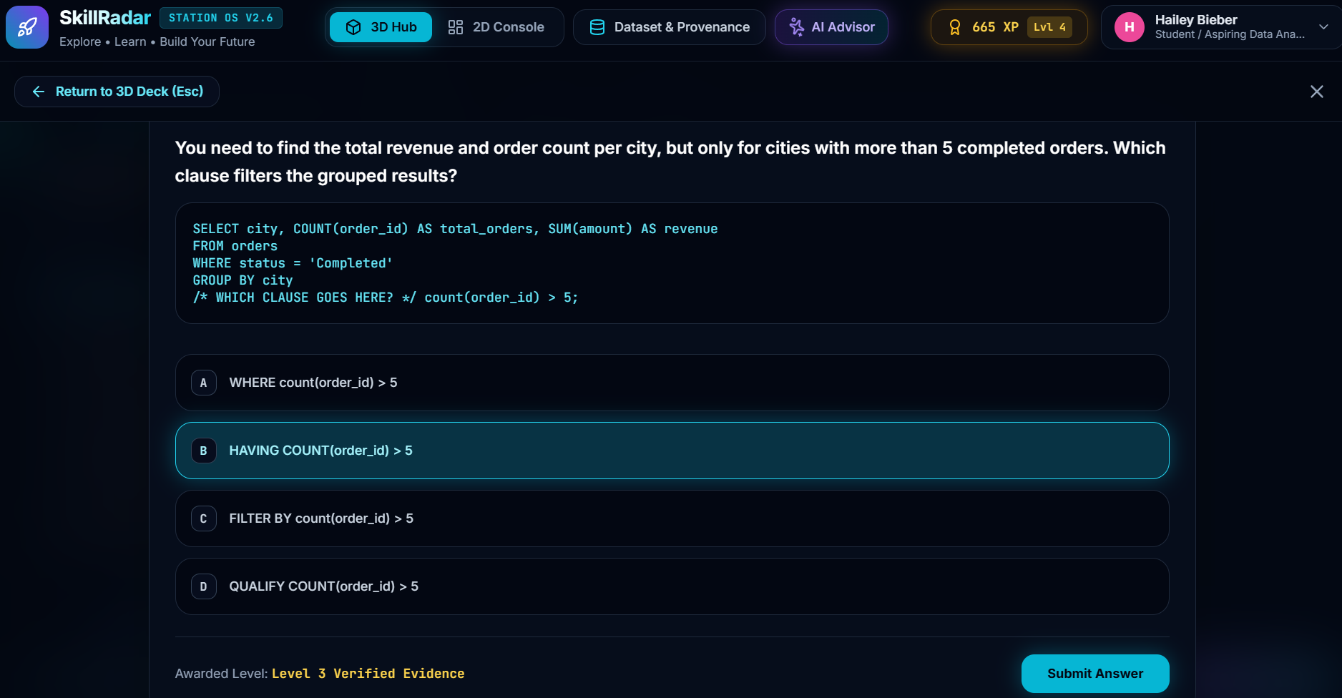
Fig. 5: Answer options with the awarded level shown as verified evidence
In Self-Assessment (Fig. 6) the student rates a skill from L1 to L5 after reading its definition, and may add where the skill was learnt. These entries stay tagged as unverified. The Evidence Ledger (Fig. 7) lists everything recorded so far with colour tags for Quiz, Simulation and Self-Reported. In the demo profile, SQL and Excel are quiz-verified, while Python and Communication are self-reported.
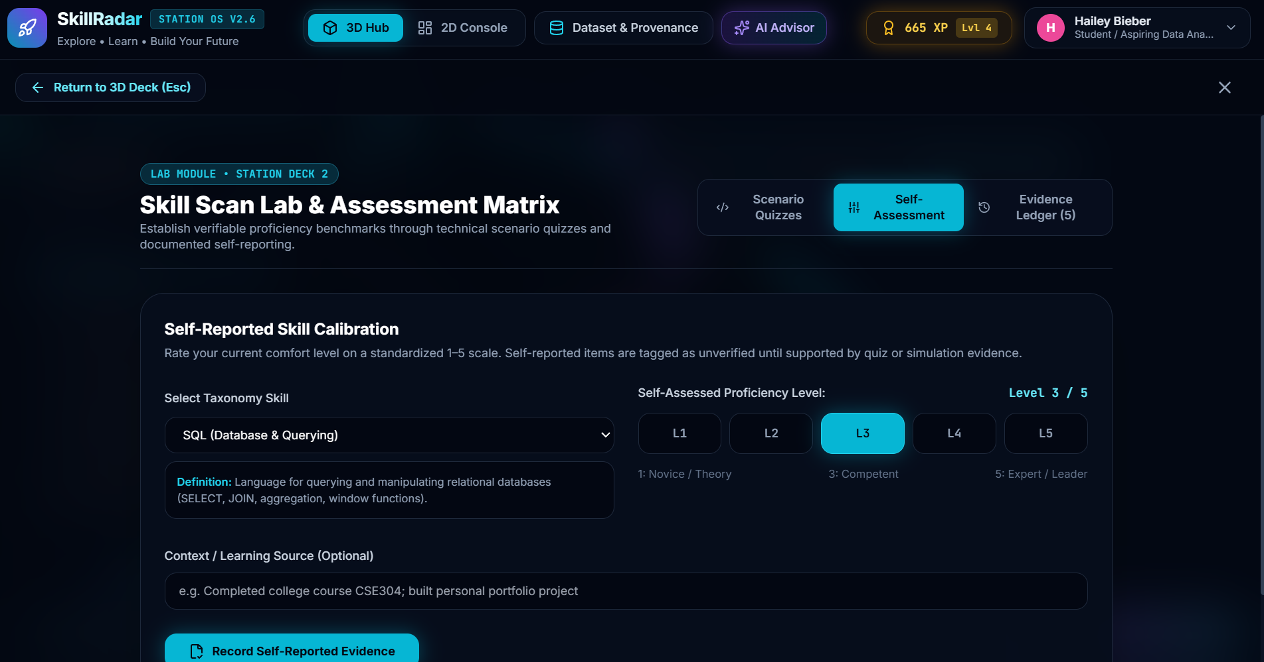
Fig. 6: Self-assessment with the taxonomy definition of SQL
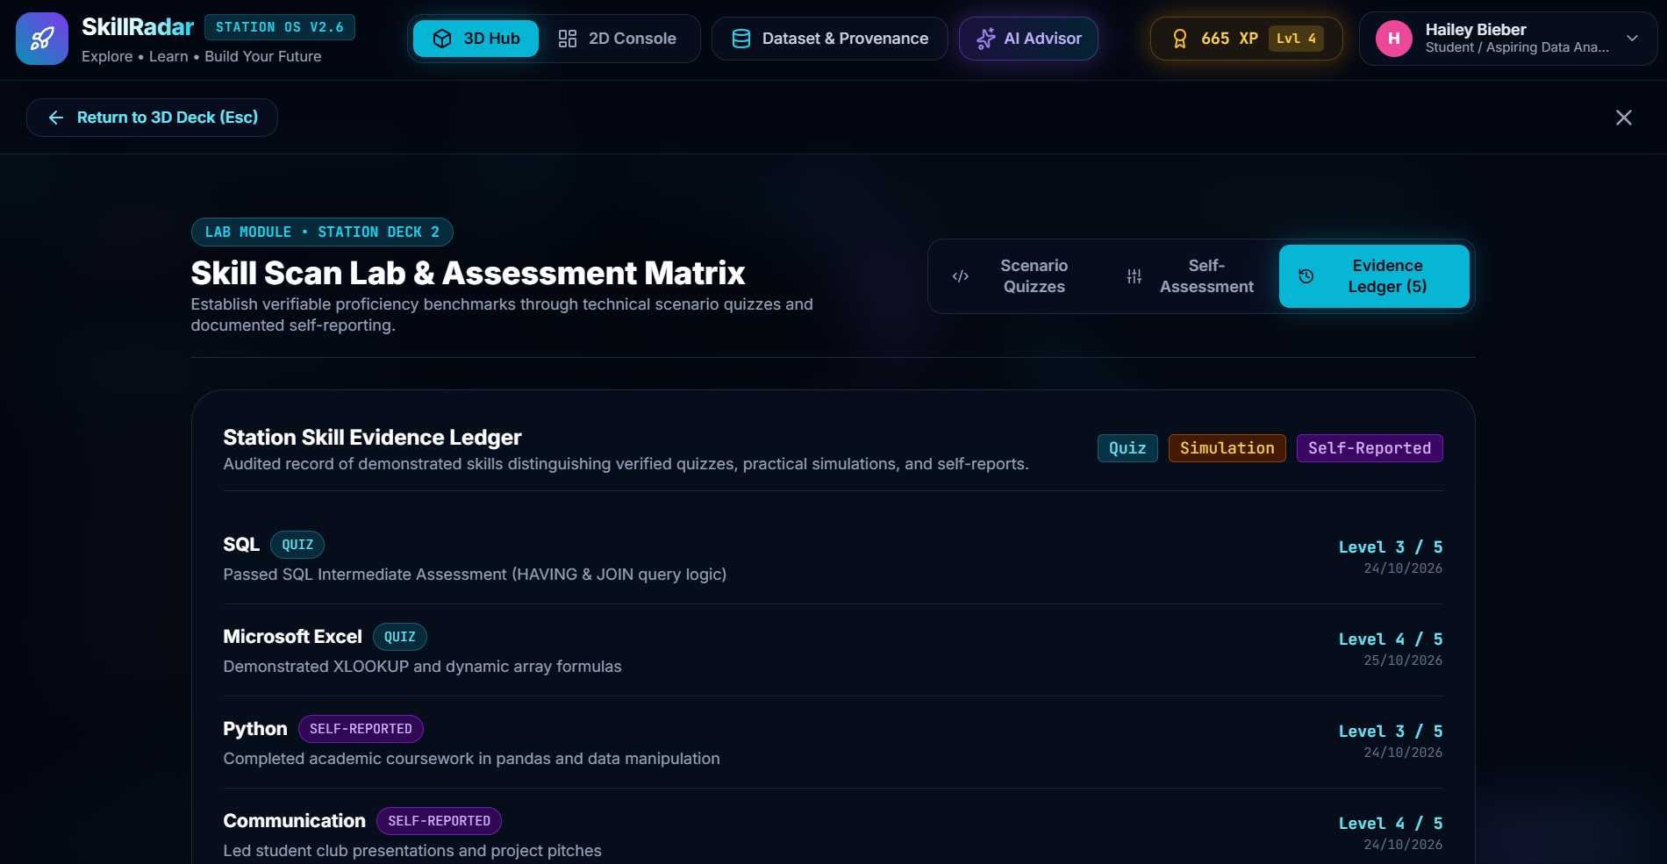
Fig. 7: Station Skill Evidence Ledger
Table III: Skill categories covered by the scenario quizzes
Category | Type of scenario used
SQL | Filtering, grouping and joining data, for example choosing between WHERE and HAVING
Microsoft Excel | Lookup functions such as XLOOKUP and dynamic array formulas
Python | Data handling with pandas and basic data manipulation
Power BI | Building measures and reading dashboards
Statistics | Interpreting averages, spread and simple tests
Problem Solving | Business situations where the student has to decide what to check first

Every quiz question has a short explanation that appears after the student answers, so even a wrong answer becomes a small lesson. The level that is awarded depends on the difficulty of the question, which is why the intermediate SQL question in Fig. 4 gives Level 3. The result is written to the evidence ledger immediately with today’s date, so the Check My Fit score and the gap analysis use the new evidence without any extra step.
5.4 Career Explorer
Here the student can search the 66 roles by title, skill or description and filter by category (Fig. 8). The detail panel shows the role purpose, salary percentiles in lakhs, number of matching postings and top hiring cities. For Data Analyst the dataset has 67 postings with a median salary of ₹6.0 lakh per year (₹4.0 lakh at the 25th percentile and ₹13.0 lakh at the 75th). A role can be set as the current goal, or the student can go straight to Check My Fit.
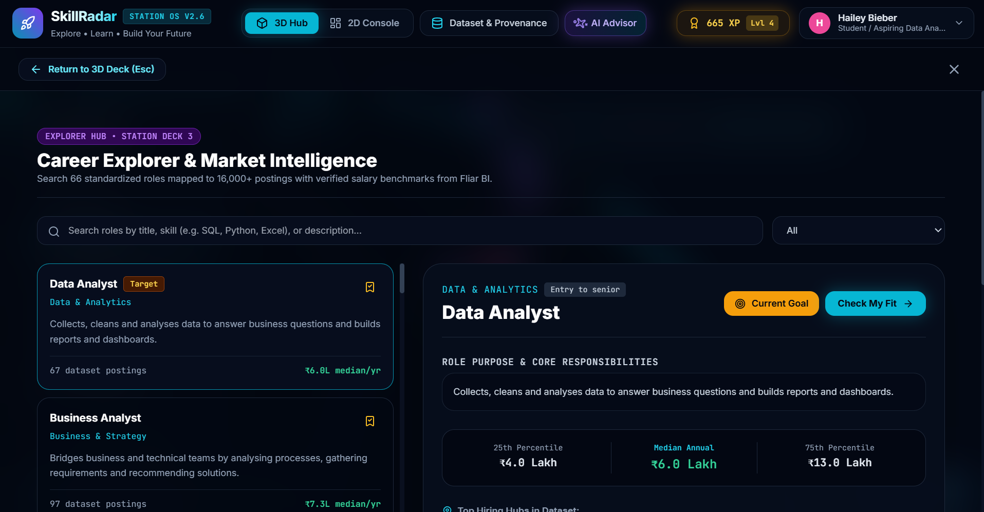
Fig. 8: Career Explorer showing the Data Analyst role and salary percentiles
5.5 Role Match Command Center (Check My Fit)
This room applies Eq. 1 to the selected role (Fig. 9). It displays the alignment score, the formula and weights in plain words, the evidence completeness, and four counters for matched, partial, gap and unassessed skills.
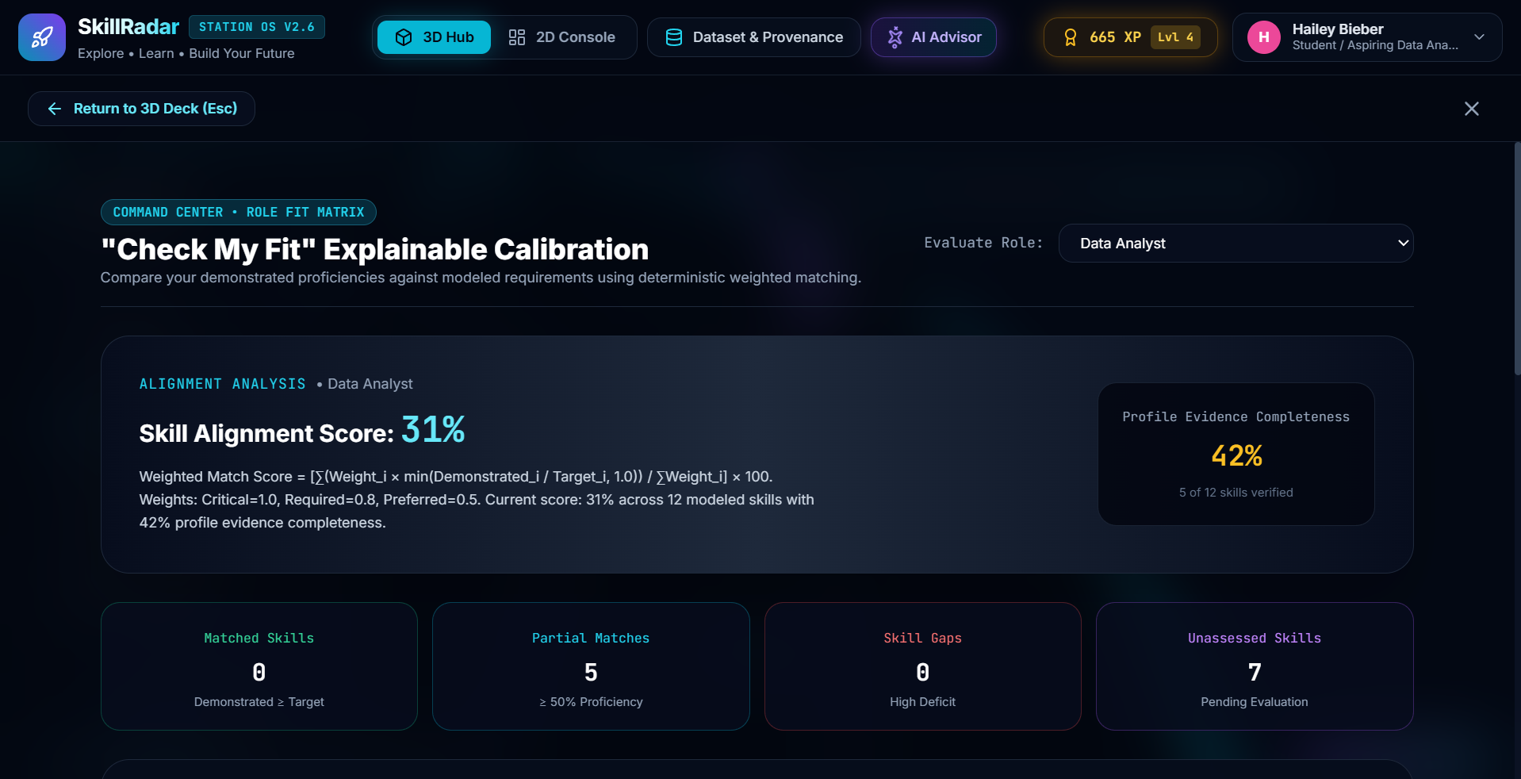
Fig. 9: “Check My Fit” explainable calibration for Data Analyst
5.6 Job Simulation Arena
The arena has three scenarios of about 15 to 20 minutes each, with three practical tasks per scenario (Fig. 10). The Data Analyst case covers anomaly triage in transactions, an in-memory SQL sandbox (SELECT, WHERE, GROUP BY, ORDER BY) and a funnel diagnosis across regions. The Financial Analyst case has liquidity and solvency ratios, margin analysis and a capital investment recommendation. The Business Analyst case has MoSCoW prioritisation, a workflow bottleneck analysis and acceptance criteria in Given / When / Then format.
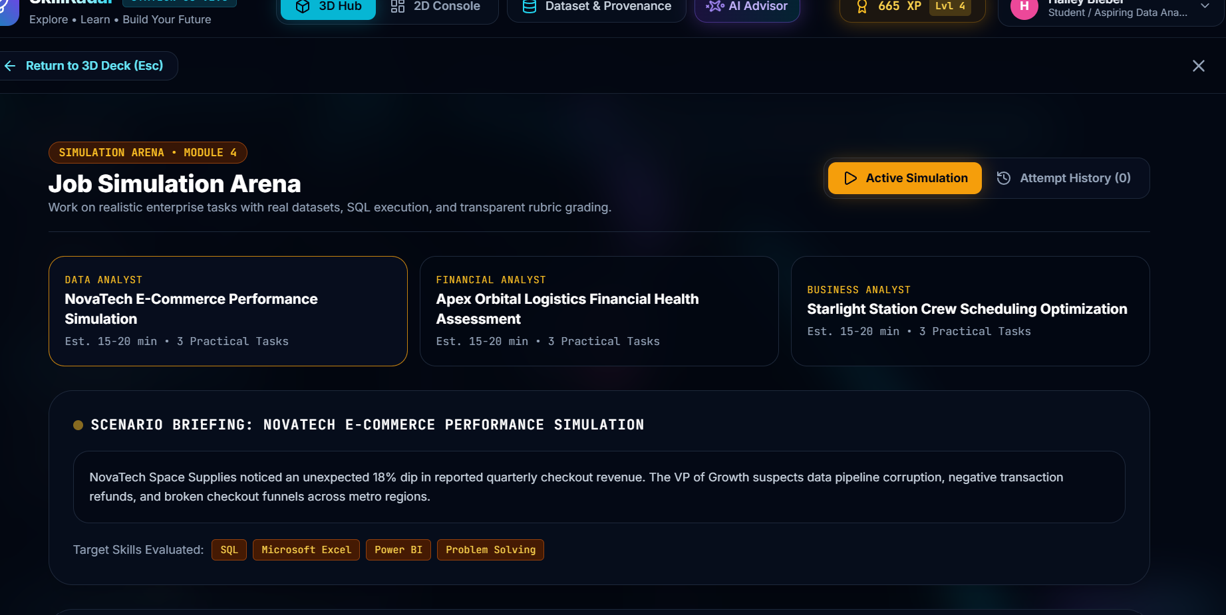
Fig. 10: Job Simulation Arena with the NovaTech e-commerce scenario
To give a feeling of the Data Analyst scenario, NovaTech Space Supplies is a fictional company whose quarterly checkout revenue has dropped by 18%. The VP of Growth suspects corrupted data, negative transaction refunds and broken checkout funnels in some metro regions. The student has to find the bad records, query the data in the built-in SQL sandbox and explain where in the funnel customers are being lost. The skills tested in this scenario are SQL, Microsoft Excel, Power BI and Problem Solving, and they are shown as tags on the scenario card.
After the student submits, the rubric gives itemised points for each task along with feedback that explains what was correct and what was missed. The attempt is saved, and the Attempt History tab keeps a record of all graded runs. A successful simulation also counts as evidence in the ledger, which is stronger than a self-report.
5.7 Skill Gap Analysis and Skill Upgrade Station
The gap screen compares demonstrated and target levels for each skill (Fig. 11). In the demo, SQL is at Level 3 from a quiz against a target of 5, a deficit of 2, while Power BI has no evidence against a target of 5, a deficit of 5. From here the student can generate a roadmap (Fig. 12). The page clearly states the grounding policy that reading documentation alone does not mark a skill as mastered.
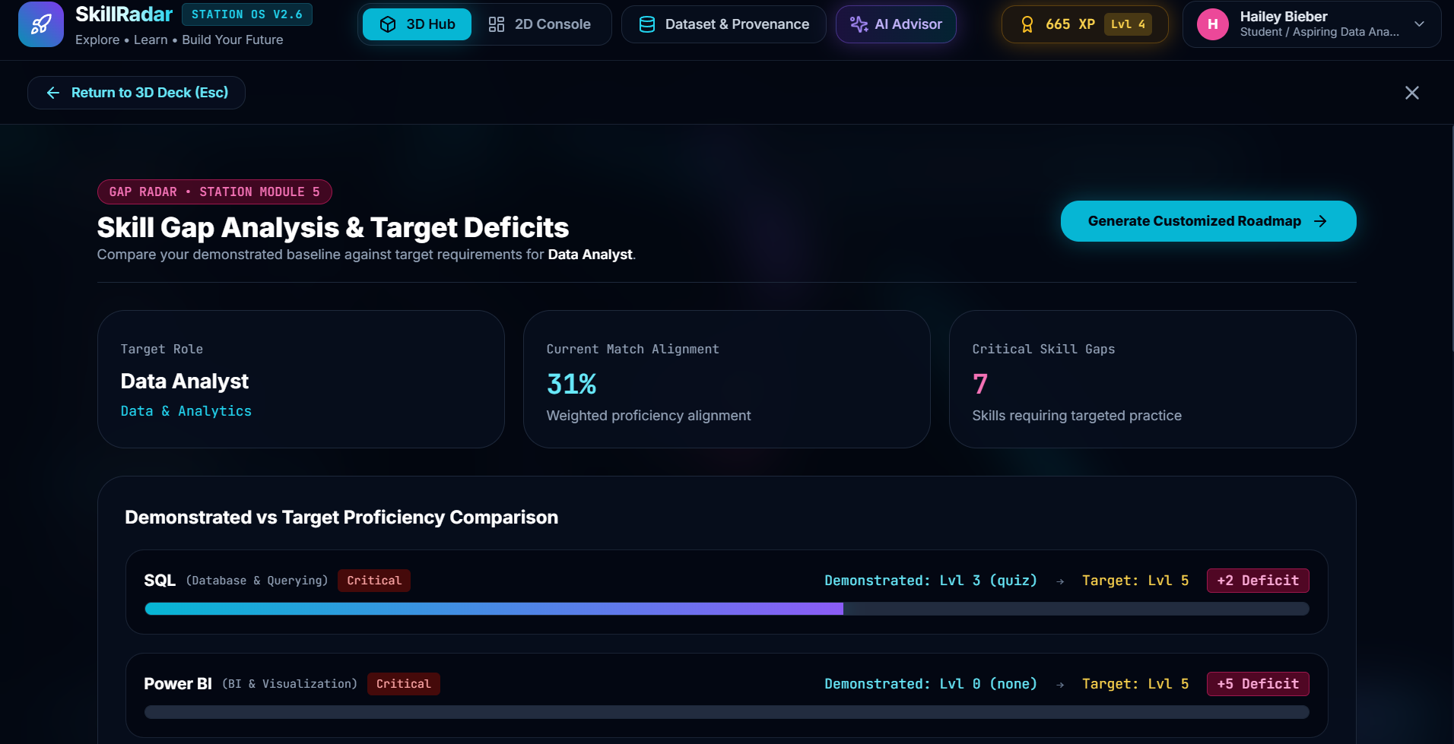
Fig. 11: Skill gap analysis: demonstrated versus target proficiency
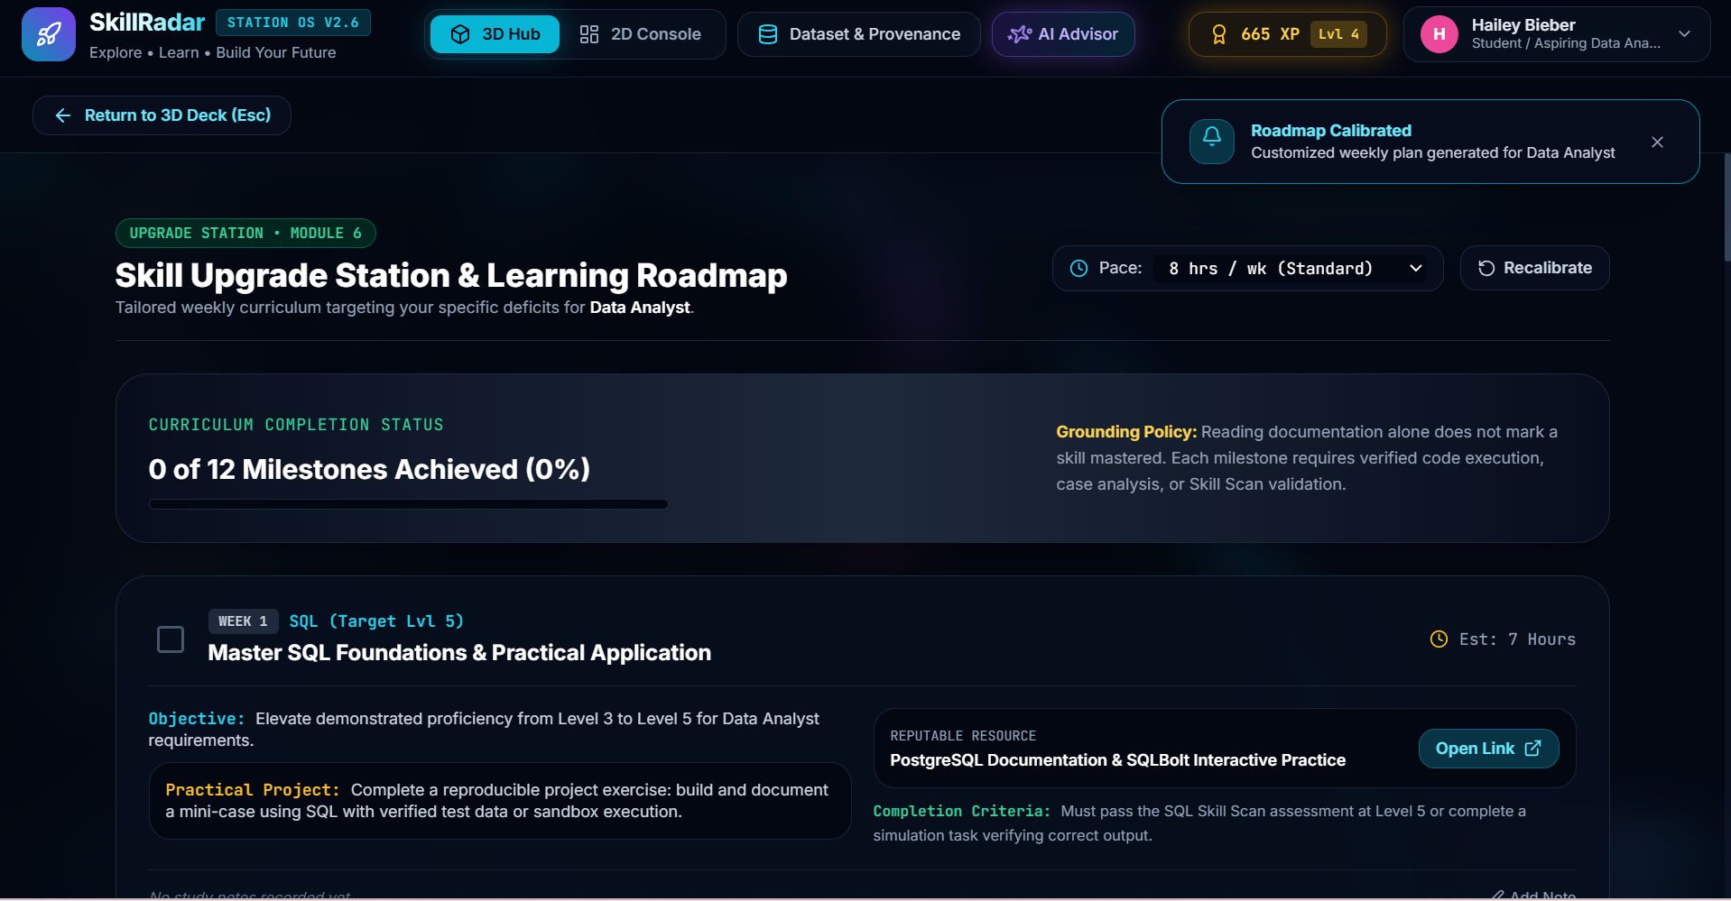
Fig. 12: Skill Upgrade Station and Learning Roadmap (Week 1: SQL)
Each milestone of the roadmap contains the week and the skill it targets, an objective (for instance raising SQL from Level 3 to Level 5 for Data Analyst requirements), a practical project, a link to an official learning resource such as the PostgreSQL documentation and SQLBolt, an estimated time in hours, and the completion criteria. Students can tick milestones, write study notes for each one and recalibrate the plan whenever they change their weekly pace between 4, 8, 15 and 20 hours.
The completion criteria are intentionally strict. For the SQL milestone the student must pass the SQL Skill Scan assessment at Level 5 or finish a simulation task that verifies the correct output. This follows the grounding policy shown on the page, which says that reading documentation alone does not mark a skill as mastered.
5.8 Command Center Bridge
The command center (Fig. 13) is the dashboard. It shows clearance level and XP, weighted role fit with completeness, curriculum milestones, graded simulation runs, the skill proficiency bars and the badge showcase. The “Continue Active Mission” button takes the student to the next suggested step.
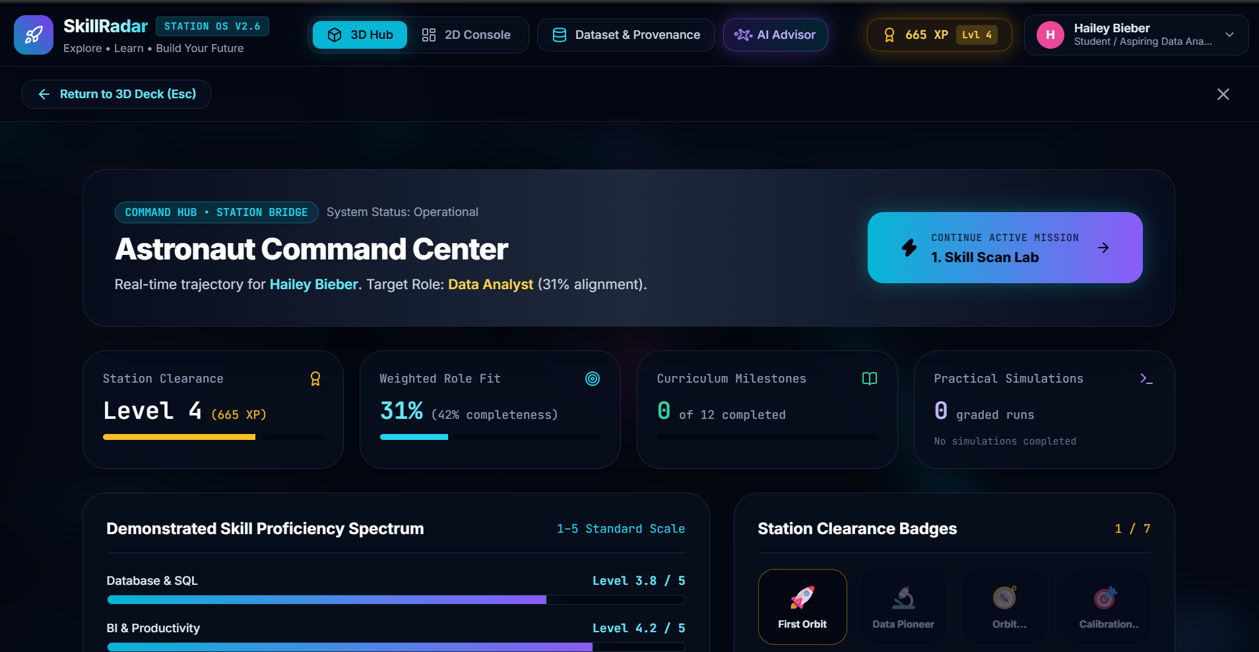
Fig. 13: Astronaut Command Center dashboard
5.9 AI Career Advisor
A floating advisor lets students ask about roles, skills, salaries and roadmap advice. Its answers come from the dataset and mention the sheet used. In Fig. 14 the advisor answers a question about Data Analyst skills from the extracted-skills sheet and lists SQL, Power BI, Communication, Problem Solving and Python as critical skills with a target of Level 5.
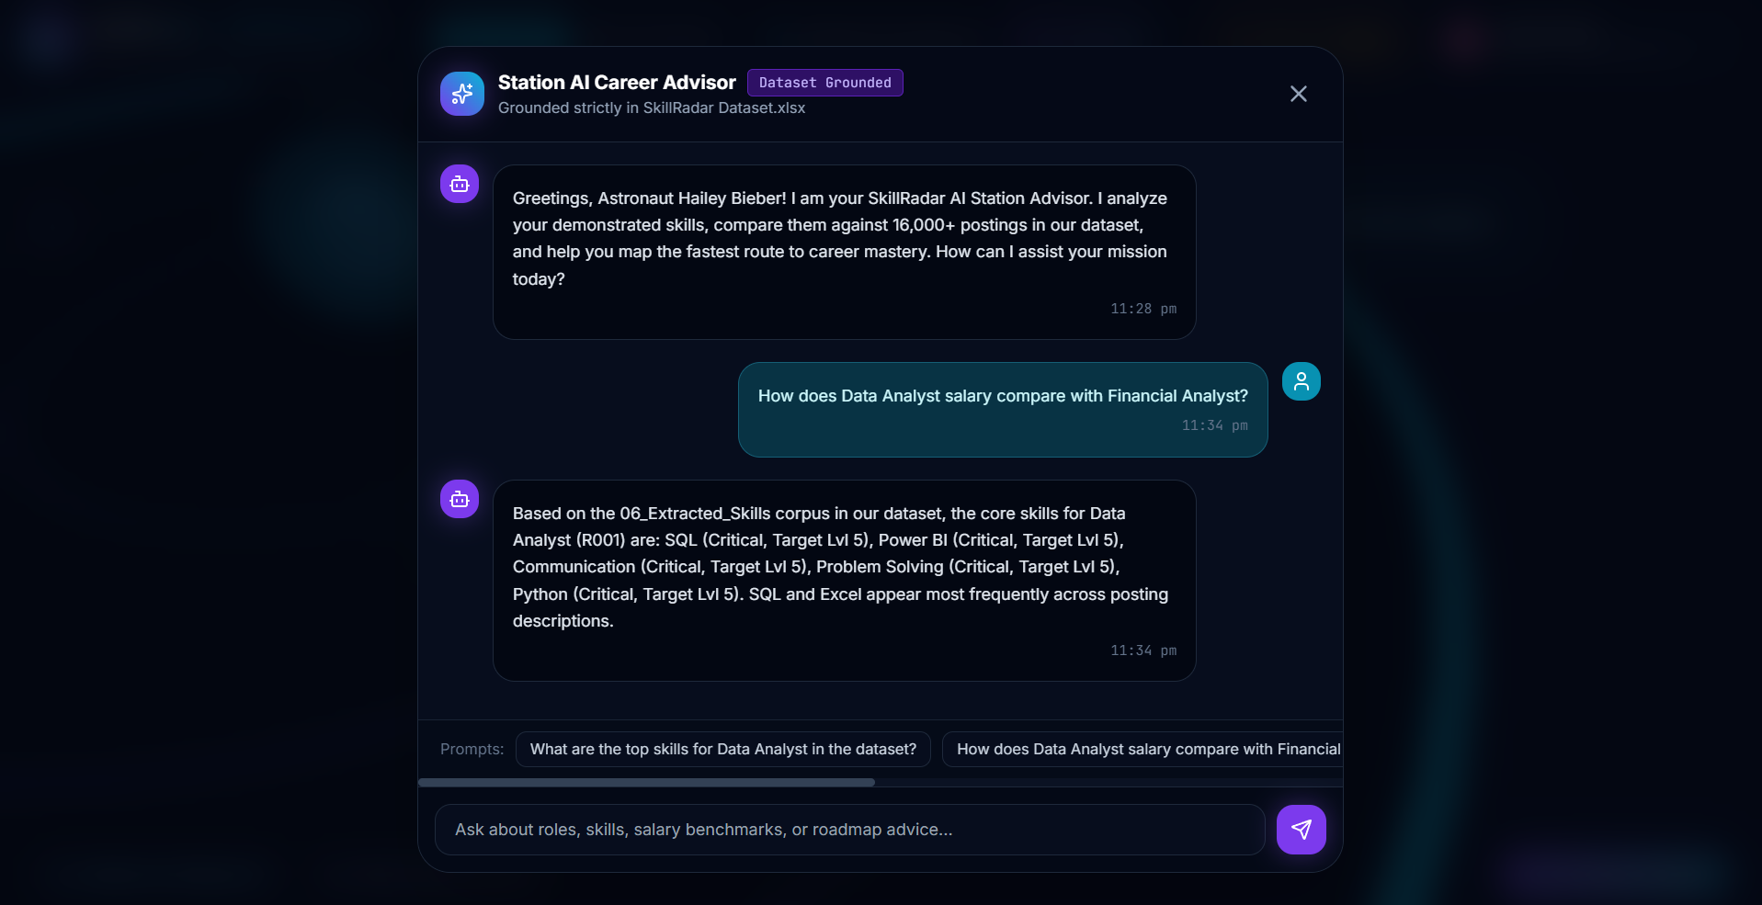
Fig. 14: Dataset-grounded AI Career Advisor
5.10 Mission board, hub radar and sound
Apart from the seven rooms, there are three small features that help the student move around. A collapsible mission board on the left shows the journey progress in percentage. A circular radar map at the bottom left shows the position of every room and of the student, and clicking a blip lets the student fast-travel there. Finally, simple sci-fi beeps and milestone chimes are produced using the Web Audio API, so the project does not depend on any external sound files.
5.11 Summary of the modules
Table IV: Summary of the seven rooms and what each one produces
Room | What the student does | What the system produces
Station Lobby | Enters profile details and picks suit colour | Profile, default target role
Skill Scan Lab | Takes quizzes and rates own skills | Evidence ledger with levels and types
Career Explorer | Searches and compares roles | Salary percentiles, skills, hiring cities
Check My Fit | Selects a role to evaluate | Alignment score and evidence completeness
Simulation Arena | Solves three practical tasks | Rubric-graded result and attempt history
Upgrade Station | Chooses weekly study pace | Weekly roadmap with milestones
Command Center | Reviews progress | XP, level, badges and next mission

6. MODEL EVALUATION
Apart from the seven rooms, the Dataset.xlsx workbook also stores the work of two machine learning models. Sheet 08 holds the features, sheet 09 holds the predictions and sheet 10 holds the evaluation metrics. The first model is a role classifier, which reads a job posting and predicts which of 23 role families it belongs to (for example software-eng, sales, finance, marketing or healthcare). The second is a salary model, which predicts the annual salary of a posting in lakh rupees.
Since the whole idea of SkillRadar is to be honest with the student, we did not want to show these models without checking how good they really are. We therefore added a “Model Evaluation” view with three tabs (Role classifier, Salary model and Confusion matrix). Every number in this view is recomputed from the 09_Predictions sheet on a test split of 1,980 job postings, so nothing is typed in by hand.
6.1 Why we evaluated the models
A model that gives an answer without telling us how often it is wrong can easily mislead. For a career platform this matters, because a wrong role label or a very wrong salary can push a student in the wrong direction. By evaluating on postings that the model did not see while learning, we get a fair idea of how it behaves on new data. We also compared every model with a very simple baseline, because a model is only useful if it clearly beats an easy guess.
6.2 Metrics used
Table V explains the metrics that appear in the evaluation view, in the same plain language that we used in the application.
Table V: Metrics used to judge the two models
Metric | Meaning
Accuracy | All correct predictions divided by all postings. It is the overall hit rate.
Precision | Out of the postings the model labels as a role, how many really belong to it.
Recall | Out of all real postings of a role, how many the model manages to find.
F1 score | The balance of precision and recall in one number, where 1.0 is perfect.
Macro-F1 | Average F1 where every role family counts equally, big or small.
Weighted-F1 | Average F1 where big role families count more.
Baseline accuracy | Accuracy of a lazy model that always guesses the most common role (software-eng).
Calibration error | How far the model’s confidence is from its real accuracy. Smaller is better.
MAE | Average salary error in lakh rupees.
RMSE | Like MAE, but big mistakes are punished more.
R² | Share of the variation in salary that the model explains. Below zero means worse than guessing the average.
Median % error | The typical error as a percentage of the real salary.
Within ±25% / ±50% | Share of postings where the predicted salary is close to the real one.

6.3 Role classifier results
The first tab of the evaluation view (Fig. 15) shows the headline numbers of the role classifier. The model reached an accuracy of 82.4%, which means 349 of the 1,980 test postings were labelled wrongly. The always-guess-software-eng baseline reaches only 24.7%, so the classifier is more than three times better than the easy guess.
Table VI: Headline results of the role classifier (1,980 test postings)
Measure | Value
Accuracy | 82.4% (349 wrong out of 1,980)
Macro-F1 | 0.841
Weighted-F1 | 0.827
Baseline accuracy | 24.7%
Mean confidence | 80.8%
Calibration error | 0.021

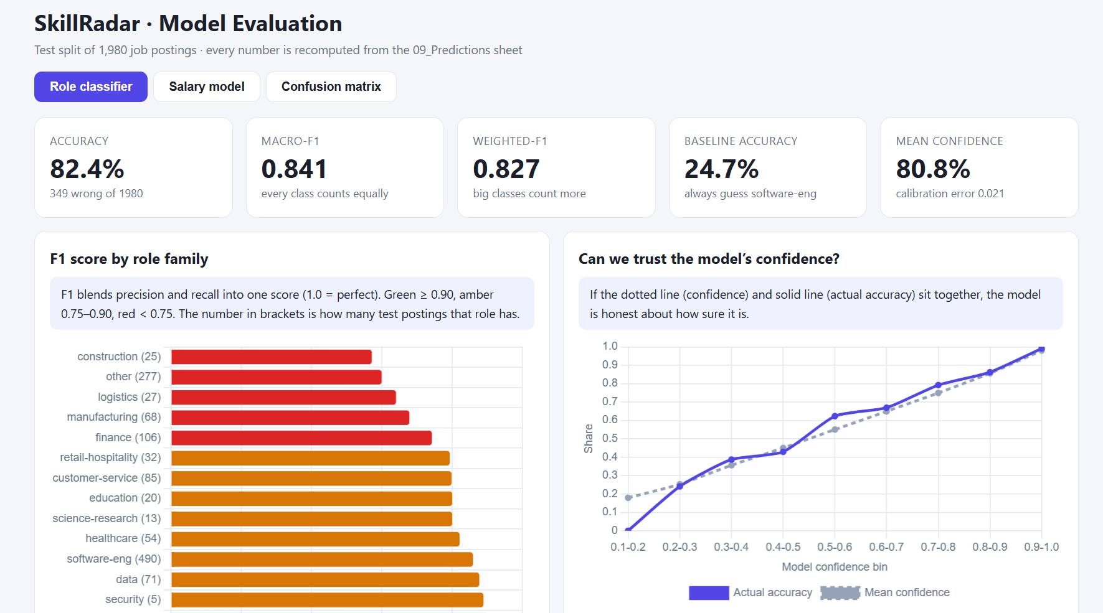
Fig. 15: Role classifier: headline metrics, F1 score by role family and confidence check
The bar chart on the left of Fig. 15 shows the F1 score of every role family, sorted from the weakest to the strongest, with the number of test postings given in brackets. Red bars are below 0.75, amber bars are between 0.75 and 0.90 and green bars are 0.90 or higher. The weakest families are construction (25 postings), other (277), logistics (27), manufacturing (68) and finance (106). Two reasons are easy to see. Construction and logistics have very few test postings, so a few mistakes change the score a lot, and “other” is a mixed bucket that does not have a clear shape. The macro-F1 (0.841) being a little higher than the weighted-F1 (0.827) also fits this, because the large and mixed “other” group pulls the weighted value down.
6.4 Can we trust the model’s confidence?
The right side of Fig. 15 compares the confidence the model reports with how often it is actually right. If the solid line (actual accuracy) and the dotted line (mean confidence) sit together, the model is honest about how sure it is. In our case the two lines stay very close, the mean confidence is 80.8% against an accuracy of 82.4%, and the calibration error is only 0.021. In the middle confidence bins the solid line is slightly above the dotted one, which means the model is a little under-confident there, and that is a safe direction to be wrong in.
6.5 Confusion matrix analysis
The confusion matrix (Fig. 16) is a 23 × 23 grid in which every row is the true role family and every column is the predicted one. The blue boxes on the diagonal are correct predictions and the red boxes are mistakes, where a darker colour means more postings. In total 1,631 of the 1,980 postings sit on the diagonal (82.4%) and the other 349 are mistakes. By recall, the best families are legal (100%), admin (98%) and operations (95%), and the worst are construction (56%), logistics (59%) and manufacturing (60%).
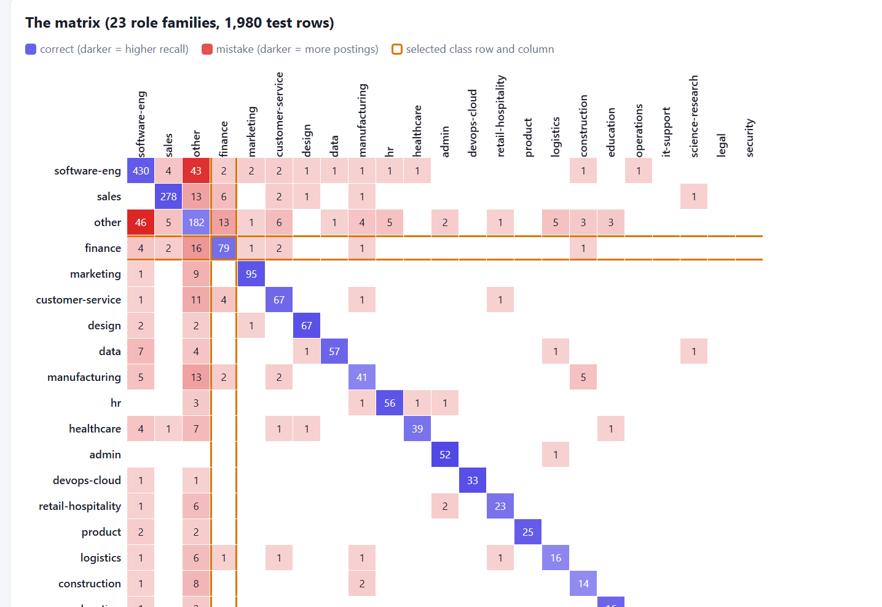
Fig. 16: Confusion matrix of the role classifier (rows: true role, columns: predicted role)
The application also lets us zoom in on a single role family, which turns the big matrix into four simple numbers. Table VII shows this for finance. Out of 106 real finance postings the model found 79 and missed 27, and it also wrongly labelled 28 other postings as finance. This gives a precision of 73.8%, a recall of 74.5% and an F1 of 0.742, which matches the amber-red position of finance in Fig. 15.
Table VII: Zoom on the finance role family
Cell | Count | Meaning
True positive | 79 | Real finance posting, predicted as finance
False negative | 27 | Real finance posting, but missed
False positive | 28 | Other posting wrongly labelled as finance
True negative | 1,846 | Correctly not labelled as finance

Fig. 17 lists the ten most common mistakes, read as “true role to predicted role”. The two biggest confusions are other to software-eng (46 postings) and software-eng to other (43 postings). This is not surprising because the “other” bucket probably contains many technology-flavoured postings that look like software jobs. Most of the remaining mistakes also end in “other”, for example finance (16), sales (13), manufacturing (13) and customer-service (11), which tells us that the model’s main weakness is deciding when a posting does not clearly fit a family, and not mixing up two well-defined families.
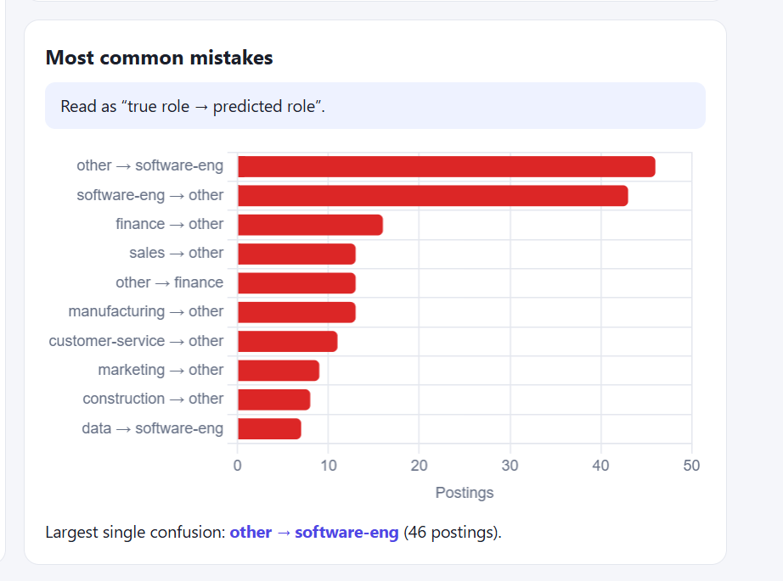
Fig. 17: Ten most common mistakes of the role classifier
6.6 Salary prediction model
The second tab of the evaluation view (Fig. 18) deals with the salary model. Table VIII compares it with a simple baseline that guesses the median salary for every posting. The model is better on every measure: its average error is ₹4.71 lakh against ₹6.87 lakh, its R² is 0.423 against a negative value for the baseline, and its typical error is 33.9% against 56.0%. About 37% of the postings are predicted within ±25% of the real salary and 67% within ±50%.
Table VIII: Salary model compared with the median-guess baseline
Measure | Our model | Baseline
MAE (average error) | ₹4.71 lakh | ₹6.87 lakh
RMSE | ₹10.29 lakh | ₹14.24 lakh
R² | 0.423 | -0.104
Median % error | 33.9% | 56.0%
Within ±25% / ±50% | 37% / 67% | not shown

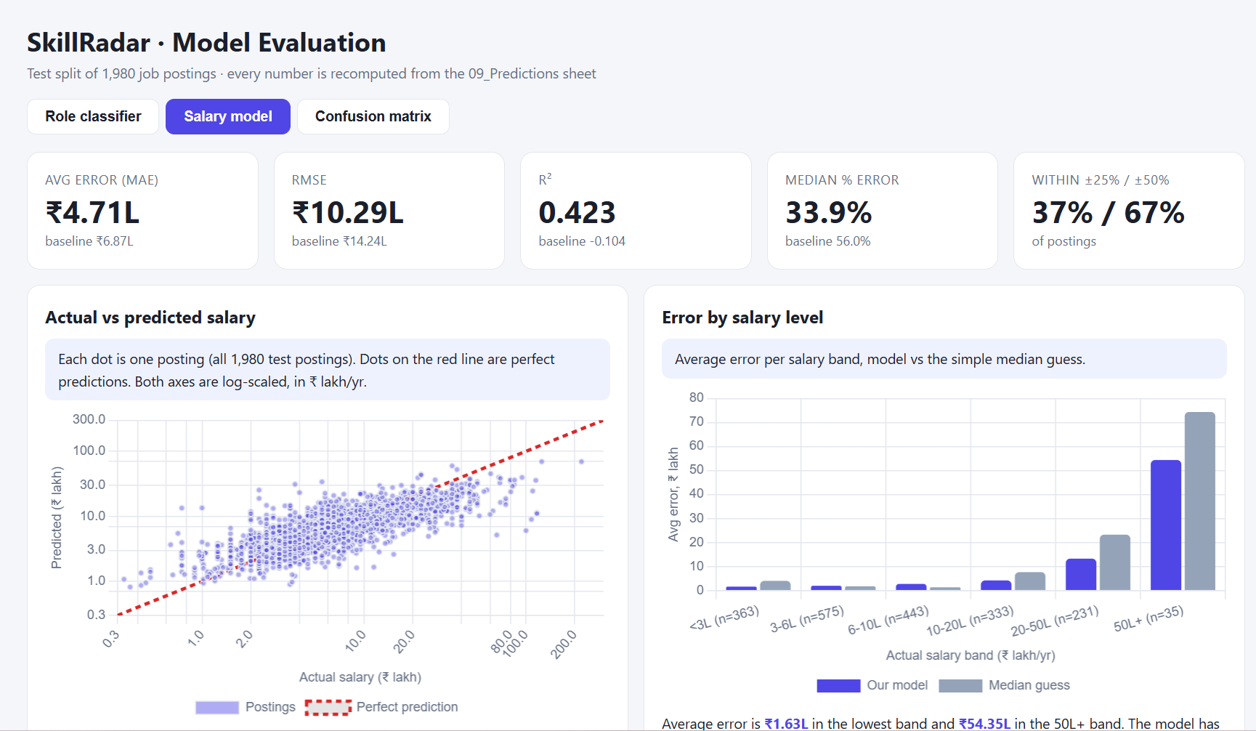
Fig. 18: Salary model: actual versus predicted salary and average error by salary band
In the left chart of Fig. 18 every dot is one posting, plotted on a log scale, and a dot on the red dashed line would be a perfect prediction. Most of the dots follow the line in the middle range, but they spread out at the very low and very high ends, and for the highest salaries (above about ₹80 lakh) the predicted value is clearly lower than the real one. The right chart splits the error by salary band. The average error is just ₹1.63 lakh in the lowest band but goes up to ₹54.35 lakh in the 50L+ band, and the model still beats the median guess in the higher bands. So the model is useful for typical salaries but not reliable for rare, very high-paying postings.
Table IX: Number of test postings in each salary band
Salary band (₹ lakh per year) | Postings | Share of test set
Below 3L | 363 | 18.3%
3L to 6L | 575 | 29.0%
6L to 10L | 443 | 22.4%
10L to 20L | 333 | 16.8%
20L to 50L | 231 | 11.7%
50L and above | 35 | 1.8%

6.7 What we learnt from the evaluation
• Role classifier: The role classifier is good enough for sorting postings into families (82.4% accuracy, well calibrated), but it is weakest on the mixed “other” group and on small families.
• Salary model: The salary model beats the baseline, but a median error of about 34% means its outputs should be treated as rough estimates.
• Use in SkillRadar: Because of this, the Career Explorer shows salary percentiles that are calculated from real postings, and we do not present model predictions as facts.
• Next improvements: More examples for the small families, a clearer definition of “other” and more very high-salary postings would be the first things to improve the models.
7. SOURCE CODE, DEPLOYMENT AND MARKET ESTIMATE
Besides the application itself, we also took care of the things that make a project usable outside our own laptops. We stored the code in a GitHub repository, deployed the website online, added an AI assistant inside the platform and estimated how big the market for such a tool could be. These four points are explained in this section.
7.1 GitHub repository
We created a public GitHub repository for the project under the account jaanvi131313-collab. The repository can be opened at https://github.com/jaanvi131313-collab/SkillRadar. It uses a single main branch and, at the time of the screenshot in Fig. 19, had 5 commits. Keeping the project on GitHub gives us version history, makes it easy for all three of us to work on the same code, and lets our guides check the source directly. Table X lists the files and folders in the repository.
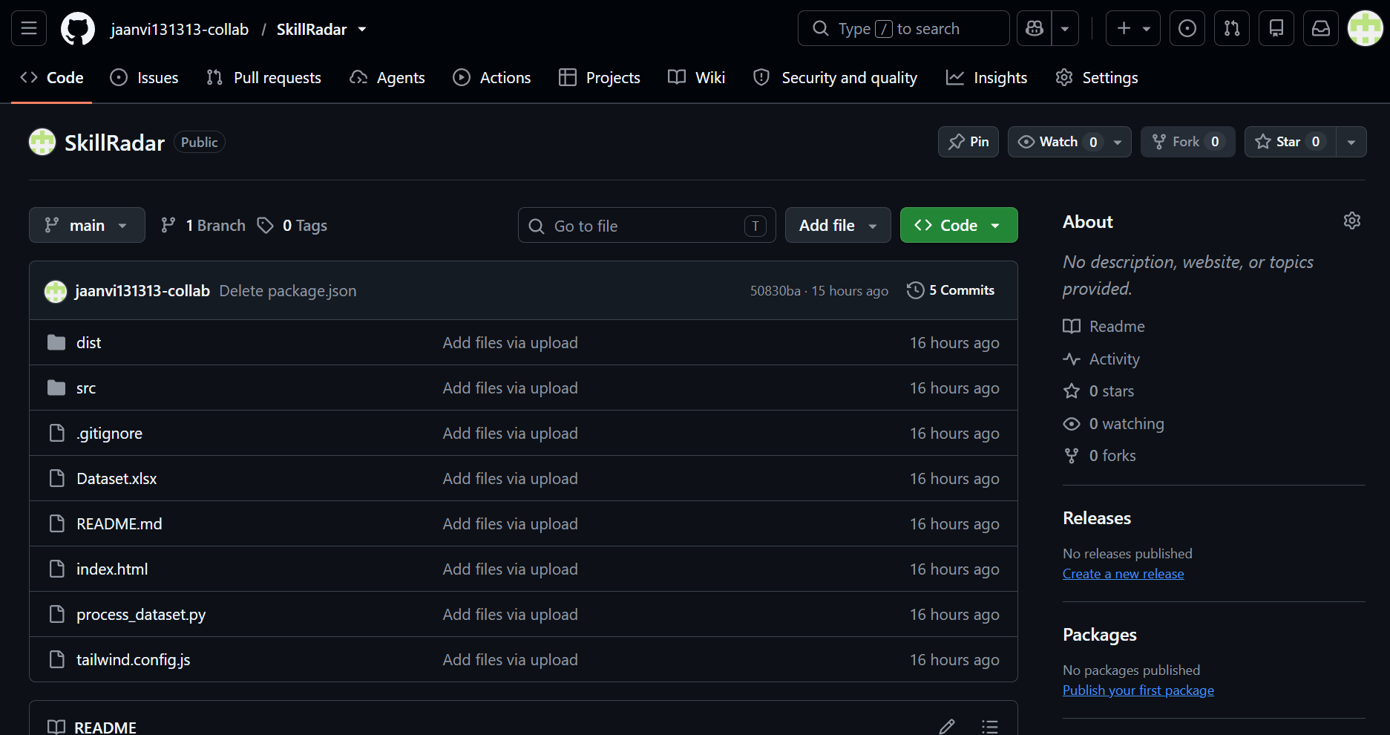
Fig. 19: SkillRadar repository on GitHub (main branch)
Table X: Files and folders in the SkillRadar repository
Item | What it contains
src | Source code of the web application
dist | Production build of the application (static files)
Dataset.xlsx | The audited 15-sheet workbook used by the platform
process_dataset.py | Python script for processing the dataset
README.md | Description of the project, quickstart and deployment steps
index.html | Entry page of the web application
tailwind.config.js | Configuration of the Tailwind CSS styling
.gitignore | List of files that Git should not track

7.2 Deployment on Vercel
The website has been deployed on Vercel, so it can be opened from a normal browser link without installing anything. This was possible because the project builds into static files, and the repository already contains a vercel.json file with the single-page-app route rewrites. When the GitHub repository is connected to Vercel, pushing a new commit can rebuild and publish the latest version automatically. Docker, Netlify and other options described in Section 4.9 are still available if we ever want to host it elsewhere.
7.3 AI assistant
We also added an AI assistant to the website, called the Station AI Career Advisor. It can be opened from the “AI Advisor” button in the top bar or from the floating “AI Career Advisor” button at the bottom right of the 3D hub. The chat window carries a “Dataset Grounded” tag with the line “Grounded strictly in SkillRadar Dataset.xlsx”, which tells the student that answers come from our dataset and not from general internet knowledge. The student can type a question or tap one of the suggested prompts, for example “What are the top skills for Data Analyst in the dataset?”.
The assistant can explain roles, skills, salary benchmarks and roadmap advice. When we asked it how to interpret the weighted Role Fit score, it explained the formula of Eq. 1 and clearly said that the score measures alignment with modelled job requirements and is not a guarantee or a probability of hiring. This matches the honest-scoring idea of the whole platform. Fig. 14 earlier shows an answer about the critical skills of a Data Analyst.
During testing we also noticed a limitation. When we asked how Data Analyst salary compares with Financial Analyst, the assistant replied with the core skills of Data Analyst instead of a salary comparison. So it sometimes gives the closest matching answer and not exactly what was asked. Improving how questions are understood is on our list for the future.
7.4 Market estimate: TAM, SAM and SOM
To see whether a platform like SkillRadar could grow beyond a college project, we made a simple estimate of the market using the TAM, SAM and SOM method. TAM is the total market if every possible student used the product, SAM is the part of that market we can realistically serve, and SOM is the share we could actually win in a few years. Fig. 20 shows the estimate and Table XI shows how each value is calculated.
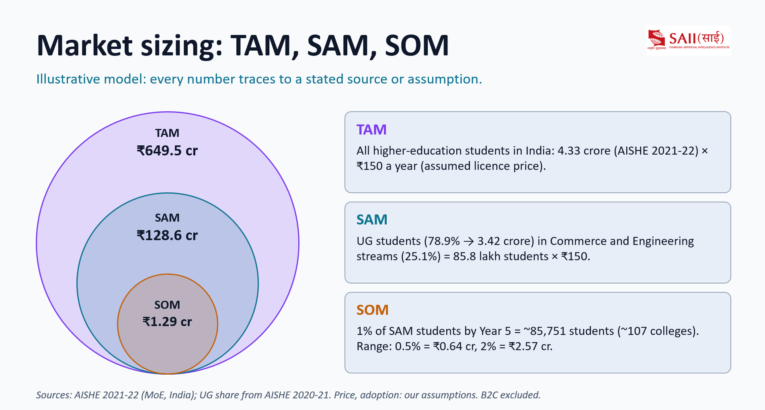
Fig. 20: Market sizing of SkillRadar: TAM, SAM and SOM
Table XI: Calculation of TAM, SAM and SOM
Level | How it is calculated | Value
TAM | All higher-education students in India (4.33 crore, AISHE 2021-22) × ₹150 per year assumed licence price | ₹649.5 cr
SAM | UG students (78.9%, about 3.42 crore) in Commerce and Engineering streams (25.1%) = 85.8 lakh students × ₹150 | ₹128.6 cr
SOM | 1% of SAM students by Year 5, about 85,751 students (about 107 colleges) | ₹1.29 cr
SOM range | 0.5% of SAM students / 2% of SAM students | ₹0.64 cr / ₹2.57 cr

The student numbers come from the All India Survey on Higher Education (AISHE) of the Ministry of Education, and the UG share is from AISHE 2020-21. The price of ₹150 per student per year and the adoption rates are our own assumptions, and direct-to-student (B2C) sales are excluded. This is why we call it an illustrative model. Even the cautious SOM of about ₹1.29 crore comes from only around 107 colleges, which seems reasonable for a platform that colleges and placement cells would license.
8. RESULTS AND DISCUSSION
8.1 Output for the demo profile
The results of running the platform with a demo profile that targets Data Analyst are summarised in Table XII.
Table XII: Output produced for the demo profile
Indicator | Value
Target role | Data Analyst
Weighted role-fit score | 31%
Profile evidence completeness | 42% (5 of 12 skills verified)
Matched / Partial / Gap / Unassessed | 0 / 5 / 0 / 7
Critical skill gaps | 7
Clearance level | Level 4 (665 XP)
Badges earned | 1 of 7
Curriculum milestones | 0 of 12
Graded simulations | 0

Table XII shows why we display completeness beside the score. A fit of 31% with only 42% of skills verified tells the student that the result is a rough one, and that seven skills are still untested. Since the formula is visible, the student can also see that finishing the Power BI quiz or the Data Analyst simulation will push both numbers up.
8.2 What we observed in each module
While testing the application with the demo profile, we checked each module one by one and noted what it produced. Table XIII collects these observations.
Table XIII: Observations from testing the demo profile module by module
Module | Observation
3D Hub | The avatar moves with the keyboard, the camera follows it and the prompt for the Simulation Arena appears near the portal.
Skill Scan Lab | The SQL quiz awarded Level 3 as verified evidence, and the ledger lists 5 entries with correct tags and dates.
Career Explorer | Data Analyst shows 67 postings and a median of ₹6.0 lakh, with 25th and 75th percentiles of ₹4.0 lakh and ₹13.0 lakh.
Check My Fit | The score came out at 31% with 42% evidence completeness, split as 0 matched, 5 partial, 0 gaps and 7 unassessed.
Skill Gap Analysis | Seven critical gaps were found, for example SQL with a deficit of 2 and Power BI with a deficit of 5.
Upgrade Station | A weekly plan with 12 milestones was generated for 8 hours per week, with the first week focused on SQL.
Command Center | Shows Level 4 with 665 XP, one of seven badges and no graded simulations yet.
AI Advisor | Answered a question about Data Analyst skills using the extracted-skills sheet and named SQL, Power BI, Communication, Problem Solving and Python.

8.3 Discussion
The evidence ledger also keeps the profile honest. Python and Communication are only self-reported, so they do not count as verified and the score is not inflated. The roadmap then turns the 31% into actual weekly work, beginning with SQL because it is the largest verified deficit. Table XIV compares SkillRadar with the usual tools we tried before building it.
Table XIV: Comparison of SkillRadar with typical job and quiz websites
Aspect | Typical website | SkillRadar
Market data | Only listings | Audited dataset with salary percentiles and provenance
Skill evidence | Single score or self-claim | Quiz, simulation and self-reported kept separate
Match score | Opaque percentage | Visible formula plus completeness warning
Next steps | Left to the user | Weekly roadmap based on gaps and study hours
Engagement | Static pages | 3D hub, XP, badges and simulations

8.4 Limitations we noticed
We also ran into a few limitations. Text-based analysis is limited to 2,057 postings because the other sources have no descriptions. The quizzes and simulations cover only three role families. The simulation grading is rule-based, so it cannot judge open-ended answers outside its rubric. Lastly, the demo numbers come from one profile and not from a user study, so we cannot claim how this affects real students yet.
9. FUTURE SCOPE
As the project grows, we see a lot of possibilities. There are several things we would like to add. More role families such as software engineering and marketing analytics can get their own quizzes and simulations. User accounts and cloud storage would let progress sync across devices. The dataset could be refreshed regularly to show hiring trends over time using the market benchmark sheet. The gold-label and prediction sheets could be used to train and properly evaluate a skill-extraction model. A faculty or placement-cell view would help track a whole batch, and multiplayer rooms with leaderboards could make learning more collaborative.
From the technical side, the next big step is to move the student data from the browser to a proper database so that profiles are not lost when a different device is used. We would also like to add automated tests for the scoring formula and the simulation rubric, so that any change in weights or tasks can be checked quickly. On the content side, more quiz questions per skill and randomised question banks will make the assessment harder to memorise. Finally, a mobile-friendly version of the 3D hub can be made so that students can use the platform from their phones.
Another useful extension is a comparison between the student’s profile and a real posting that the student pastes in. The extracted-skills approach used in the dataset could be applied to that text, and the student would immediately see which of the posting’s requirements they already meet.
10. CONCLUSIONS
In this mini project we built SkillRadar, a browser-based platform that connects job market data, skill testing, role matching, practical simulations and a weekly learning plan in one place. The main idea behind it is being honest with the student: each score shows its formula, each skill shows what kind of evidence supports it, and the weaknesses of the dataset are visible inside the product. The platform runs with only static hosting and can be deployed on Docker, Vercel, Netlify or any similar service, so it is easy to share with other students. We believe it can be extended into a fuller placement-readiness tool in the future.
We also evaluated the two machine learning models stored in the workbook, added an AI assistant to the platform, kept the code in a public GitHub repository (jaanvi131313-collab/SkillRadar), deployed the website on Vercel and estimated the market size with TAM, SAM and SOM values. The role classifier reached 82.4% accuracy on 1,980 test postings against a baseline of 24.7%, and its confidence matched its real accuracy closely. The salary model reduced the typical error from 56.0% to 33.9% compared with a median guess, but it is still only a rough estimate for very high salaries.
REFERENCES
1. Fliar BI, India Salary Benchmarks dataset (SRC001), licensed under CC BY-NC 4.0.
2. LinkedIn Tech Job Postings sample (SRC006), used as an educational research sample.
3. Headcount Labs dataset (SRC004), as listed in the source register sheet of Dataset.xlsx.
4. SkillRadar project workbook, Dataset.xlsx, README and sheets 01 to 14, 2026.
5. PostgreSQL Global Development Group, PostgreSQL Documentation, https://www.postgresql.org/docs/
6. SQLBolt, Learn SQL with simple interactive exercises, https://sqlbolt.com
7. The pandas development team, pandas documentation, https://pandas.pydata.org/docs/
8. Mozilla, MDN Web Docs, https://developer.mozilla.org
9. Khan Academy, Statistics and Probability, https://www.khanacademy.org
10. International Institute of Business Analysis (IIBA), https://www.iiba.org
11. Meta Open Source, React documentation, https://react.dev
12. Ministry of Education, Government of India, All India Survey on Higher Education (AISHE) 2021-22 and 2020-21.
13. SkillRadar source code repository, https://github.com/jaanvi131313-collab/SkillRadar

